**EE4717 Web Application Design – Project Report**

Design project group number: F35-DG16

Team members: Aaron Gangemi, Course code: EE4717

**Project Title: NTU Pizzeria online ordering service**

**Summary of Project:**

The project I will be developing will be a website for the NTU Pizzeria. The site will provide the Pizzeria’s customers with a quick and easy-to-use method of ordering their pizza online. The site will have the capacity to display to the user what pizza is offered for delivery. The user will be able to submit their order with payment and delivery details inclusive. In addition, the site will also be able to inform the user of existing deals offered by the NTU pizzeria and allow them to purchase existing promotion deals. Furthermore, the site will provide links to various pages including the menu, locate us page and user feedback review page. Once the user has ordered, the site will send the user email confirmation stating the status of the user’s order.

Table of Contents

1. Applications Requirements and Specifications 4

2. Functional Requirements and Specifications 5

3. Sitemap 7

4. Storyboard 9

5. Wireframes 10

5. Wireframe cont’d: 11

Database: 12

Customer Table: 12

Pizza Table: 13

Orders Table: 14

Web Application Design Tests: 14

Homepage Tests 14

Sign up/Login Tests 15

Menu and Promotions: (NTU Classics, Student Specials, Our Deals, Absolute Steals) 16

Locate Us: 16

Review Us: 17

Cart Controller: 17

Delivery Review: 17

Implementation: 18

Coding of the Web Page Templates: 18

Coding of Each Web Page: 18

Coding of Each Function: 19

Testing of Web Application: 20

Signup/Login Test 20

Menu and Promotions Page Test 22

Cart Controller Test: 24

Delivery Confirmation Tests: 24

Locate Us: 25

Review Us Test: 26

Conclusion: 27

What has been achieved? 27

What has been deferred? 27

Appendices: 28

Appendix: Source Codes: 28

Coding of Page Templates: 28

headerOrderNow.php 28

menuheader.php 28

promotionsheader.php 29

Coding of Each Webpage 31

index.php 31

ntuclassics.php 31

studentspecials.php 34

locateus.php 37

review.php 38

signUpLogin.php 39

promotions.php 40

promotions2.php 43

cartController.php 46

deliveryConfirmation.php 48

admin.php 50

Coding of Each Function: 53

confirmdelivery.php 53

confirmreview.php 54

create_user.php 54

CreateTable.php 55

login.php 58

logout.php 59

menucart.js 59

ntuclassicscart.php 64

promotions2cart.php 65

promotionscart.php 66

signupvalidator.js 67

studentspecialscart.php 70

updateNTUClassics.php 71

updatePromotions.php 72

updatePromotions2.php 73

updatestudentspecials.php 74

validateReview.js 75

CSS Files: 76

admin.css 76

cartcss.css 76

delivery.css 77

homepage.css 77

index.css 78

locate.css 81

menucss.css 82

promotionCSS.css 84

reviewCSS.css 86

signin.css 86

studentspecialsCSS.css 88

Appendix: Contribution to the project by each team member 88

# 

# 1. Applications Requirements and Specifications

The website will allow customers to order pizza/s from the NTU Pizzeria. The site allows customers to input their order details to the site and the pizzeria will prepare the order for delivery. The site will contain various links presented using banners, images, text and navigation bars with the end goal of directing and assisting the user to submit an order to the NTU Pizzeria. The site should display features such as the menu and existing promotion in an easy-to-use manner in order to enhance the sites usability and to ensure the user is easily able to submit their order. To do this, the following features will be incorporated:

R1 – The website will begin by featuring the home page of the site. The home page will contain the NTU Pizzeria’s logo, signup/login links, access to the main navigation bar items and various banners displaying existing promo deals offered by the NTU Pizzeria. The user/customer will be able to click on each banner to view the corresponding promotion deal.

R2 – Each page will incorporate the main navigation bar which will navigate the user to the “menu”, “promotions”, “locate us” and “review” pages. Each navigation item, when clicked will take the user to the corresponding page.

R3 – The menu page will consist of each available pizza offered by the NTU Pizzeria with its associated title, image, cost, description and an add icon.

R4 – The promotions page will display any existing promotions offered by the NTU Pizzeria. The promotions will show an image of the meal, the price of the promotion and the promotion’s description.

R5 – In order for the customer to user to contact the pizzeria, a “Locate us/Contact us” link will need to be provided. This page will contain an image of where the pizzeria is located on the map as well as the pizzeria’s contact details.

R6 – The customer will need to enter their delivery details such as name, email and delivery address for the pizza to be delivered. Therefore, the site will contain a signup/login link which after the user fills out a form to create an account, will store their delivery details.

R7 – To support the users order, the site will require a cart which will store the users/customers order for checkout.

R8 – The site will require the user to review their delivery details before the order is sent to the pizzeria.

R9 – Once the customer submits their order and order details, they will be notified of the status of their order via email.

R10 - After the customer has received their order, they will able to review the service and quality of the pizza from the home page.

R11 – The site will need to provide an FAQ page. This will answer commonly asked questions from customers. Users will be able to view the answers to these questions in the FAQ page.

R12 – The site will need to provide the user with a method to pay for the order.

# 2. Functional Requirements and Specifications

F1 – (R1) The home page will be the first page displayed. The home page will provide the user with navigation links directing the user to different aspects of the site such as the menu, existing promotions, locate us page and review page through the navigation bar. In order to make the page creative and appealing, the home page will need to contain banners of existing promotion deals offered by the pizzeria. The banners will need to extend across the entire home page to attract the user’s attention.

F2 – (R2) The navigation bar displayed on each page will contain links to the pizzeria’s menu, promotion deals, locate us link and order review form. Each of these links, if clicked will direct the user to the corresponding page. It will need to be featured on each page so the user can go to any page, thus providing quick access throughout the site. The navigation bar is an important component of the website as it acts like the GPS between pages. In order to enhance the navigation bar, the text of the bar will need to contrast with the background in order to make the navigation bar standout.

F3 – (R3) The menu page will list the variety of pizzas offered by the NTU Pizzeria. However, several pizzas onto one page can be overwhelming for the user, so I have decided to use a second navigation bar to split the menu page. The navigation bar will incorporate links to decipher between “NTU Classics” pizzas and “Student Specials”. Each pizza offered by the pizzeria will be sorted into one of the categories from the pizza navigation bar. The user can view and potentially order one of these pizzas by clicking on its category and then clicking the add icon of the pizza. Furthermore, each item on the menu will have a description and cost corresponding to the pizza displayed. Each menu item will also require a link in the form of a plus (“+”) icon which will allow the user to add the item to the cart. The item will then be added to the order and can be viewed later before checkout.

F4 – (R4) One of the features that attracts customers to the pizzeria is the existing promotions. The site will need an appealing and attractive way to display the promotions at the forefront of the site. Therefore, the promotions page can be navigated to using either the navigation bar on any page or by clicking on the existing banners being displayed on the home page. If clicked on, the promotions page will display existing promotions offered by the NTU Pizzeria. Each promotion displayed will need to display an image of the meal, a description and a promotional cost so the user knows what is included in each promotion as well as a plus (“+”) icon. If the user wishes to add the promotion to their meal, they may click on the associated plus icon which will add the promotional meal to the cart. The promotions will be sorted by the date that the promotion expires.

F5 – (R5) If the user wishes to contact or visit the pizzeria, they will require a way to find out where to go or who to contact. When the user clicks on “Locate us/Contact Us” in the navigation bar or footer content of each page, a picture of where NTU Pizzeria is located will be displayed to show the user where the pizzeria is located. A textual description of the pizzeria’s address will also be given in correspondence to the image. The page will also need to provide contact details to the pizzeria’s email address and contact number, so the user is able to contact the pizzeria.

F6 – (R6) The site will require a signup/login page which will ask the user to fill out a form to create an account and further store their user details such as name, email address and delivery details. The user will need to enter their delivery details before they order, so the site will store their details, so the user does not have to enter them every time they wish to order.

F7 – (R7) To support the users purchase of the online order, the pizzeria site will provide the user with an order cart which will store all the menu items that the user has wished to add to their order. Once the user decides to checkout, the user will click on the cart/checkout button, in which the items in the order cart will be displayed to the user for review. When the cart is displayed, the user will be presented with a customization text box. The user may enter any customizations they would like made to the order (For example, the user may enter: “I would like no pineapple on my pizza”). The user will then be asked to enter/confirm customer and payment details.

F8 – (R8) The site will require the user to review their delivery details before each order. These details are acquired when the user creates an account. This page will display and confirm with the user their name, email, order cost and delivery address. Once the user is happy with these details, they can confirm this and move to payment.

F9 – (R9) Upon submission and payment of the order, like any service, the customer will receive a confirmation email to state the status of the order such as “The order is being prepared.” The email will be obtained from the customer’s account upon signup/login and the customer will be updated upon delivery of the order status.

F10 – (R10) For feedback purposes, the site will provide the user with an option to provide feedback on the site ordering system or the service and quality provided by the pizzeria. The user can access this page through the navigation bar link “Review”. The user will be asked to fill out a textual form in which they will be able to enter their opinion of the pizzeria. Upon submission through the submission icon, the form will be sent back to the pizzeria.

F11 – (R11) The user will be assisted with an FAQ (Frequently Asked Questions) page. This page will list both commonly asked questions to the pizzeria in relation to ordering through the site. A textual description will be provided to the user answering their questions in both a clear and concise format. The user will be able to access the FAQ page in the footer content of the site.

F12 – (R12) The site will need to allow the user to pay for the purchase. Therefore, upon confirmation of delivery details, the user will be redirected to a 3rd party site for payment. If the user attempts to pay for their order and they are unsuccessful, they will be redirected back to their order delivery review page in which they will be notified that no payment was made, and the online transaction was unsuccessful. This requirement is not addressed in the storyboard, wireframe or sitemap as it is handled externally.

# 3. Sitemap

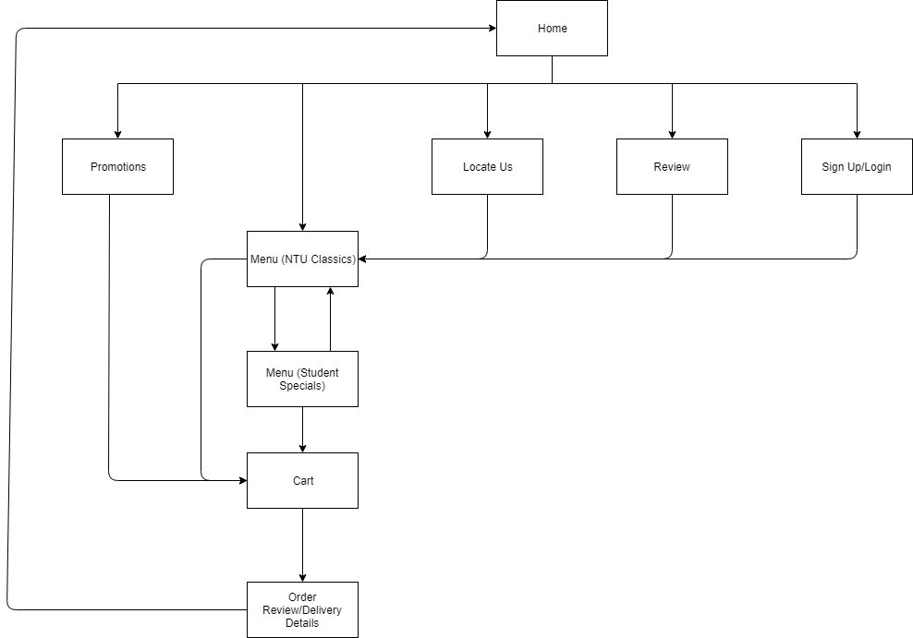

REFERENCE: Sitemap generated from draw.io

The above image is the sitemap for my pizzeria site which demonstrates the structure of the project. As mentioned in section 2, functional requirement 1, the sites first page displayed will be the home page. From the diagram, the home page will have several links to various pages throughout the site. Each page is designed to incorporate an “Order now” button and a navigation bar which will provide quick access to the menu, instead of the user having to go back to the home page to access the menu. Assuming the user is creating an order and is logged in, the user will be able to click on the menu link or the promotions link in the navigation bar (Functional requirement 2 and 3), which will display the available items offered by the pizzeria (Functional Requirements 3 and 4 for menu and promotions). The menu is split up into two pages. “NTU Classics” and “Student Specials”. Each page contains different menu items and the user may alternate between options to add different pizzas to their order. Once the user is finished with the menu and their desired pizzas have been added to the cart, the user will be able to click on the cart (functional requirement 7 of section 2) to review their order and further checkout. The cart will display the users order with the orders corresponding pricing. Finally, once the user is happy with all the items in the cart, they will be asked to confirm their customer delivery details (Functional Requirement 8) which are obtained from the users account. The user will then be directed to a 3rd party payment site (Functional Requirement 12, Section 2). After the user has finished their order, they will be sent a confirmation email which is not listed in the sitemap above, however, the email will contain the status of the order (functional requirement 9 of section 2). From here, the user will be redirected to the home page in which they will have the option to review the order and service (Functional Requirement 10, Section 2).In addition, from the home page, the user will also be able to view the locate/contact details of the pizzeria if they wish to visit or contact the store (Functional Requirement 5).

# 4. Storyboard

* References to Section 2 are below
* Requirements are in circles
* Textual description on Right hand side

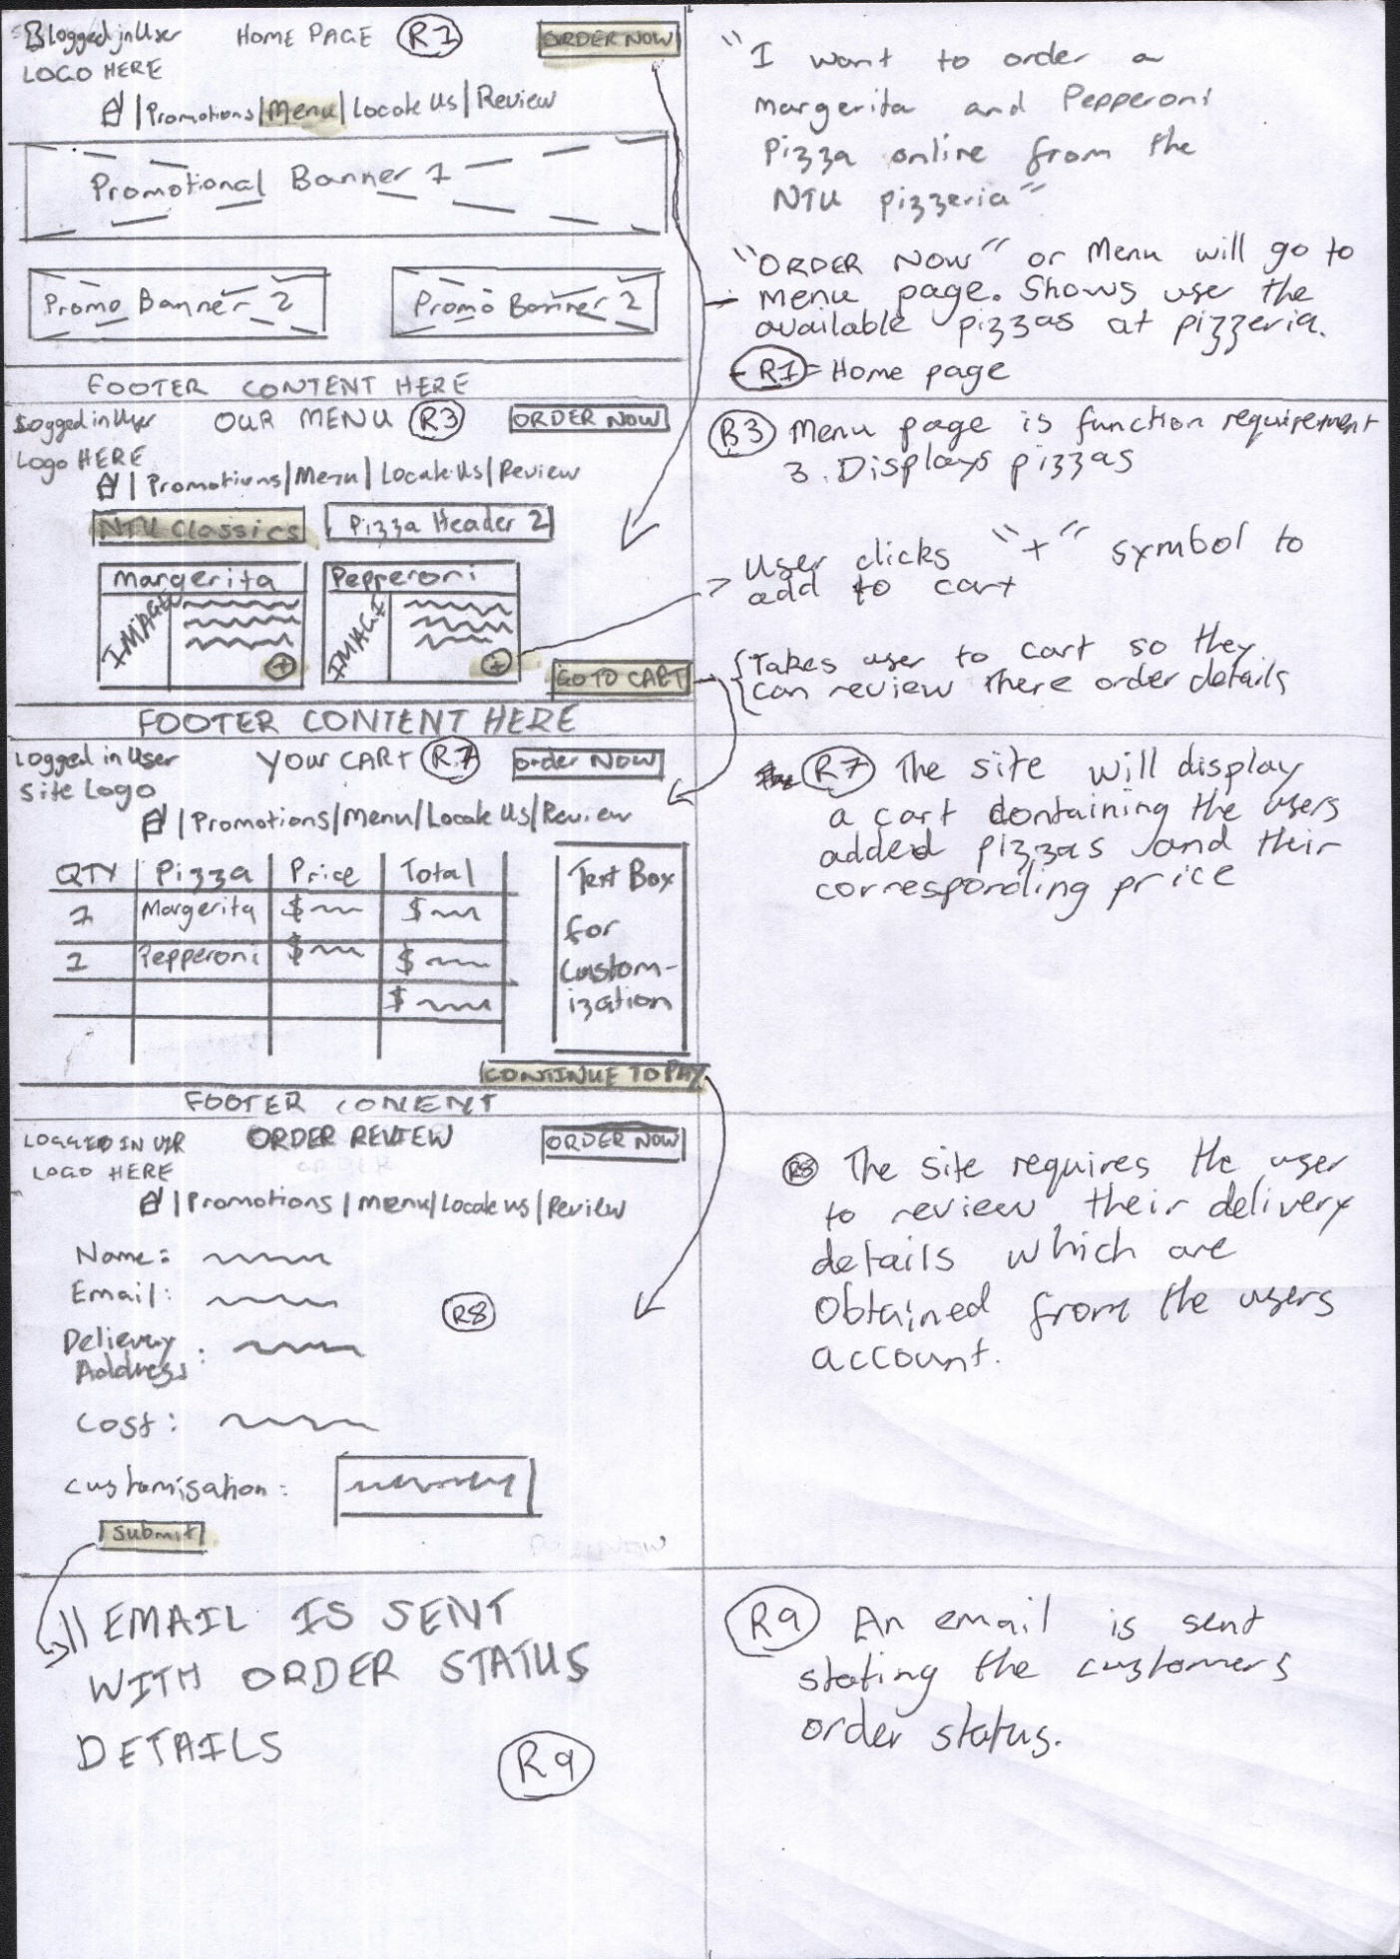

# A close up of text on a white background Description automatically generatedA close up of a map Description automatically generated5. Wireframes

# 5. Wireframe cont’d:

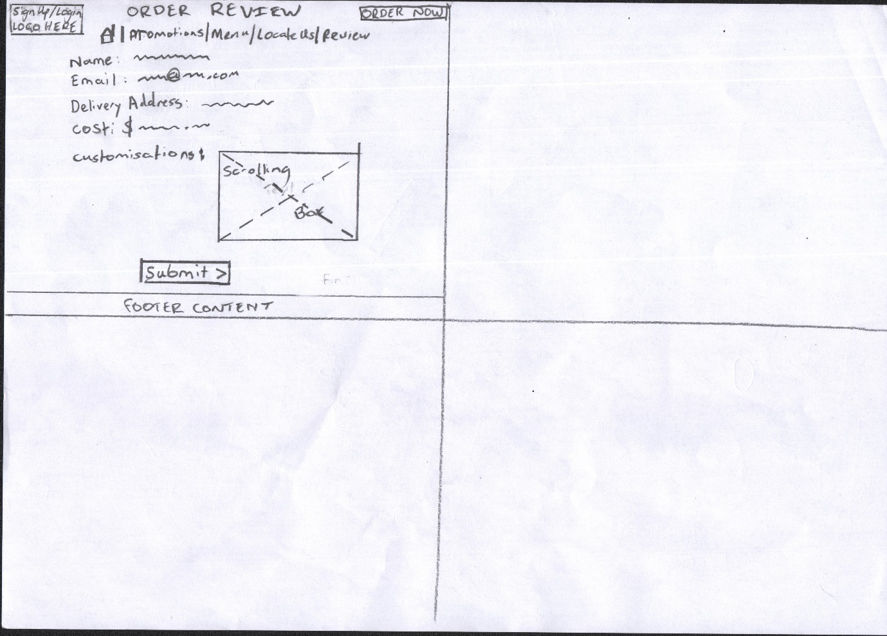

# Database:

The NTU Pizzeria database contains 3 tables. Each table is used for a different purpose throughout the site.

## Customer Table:

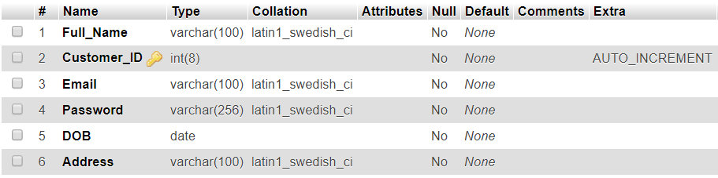***Figure 1.1:***

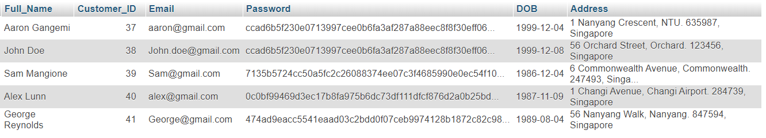***Figure 1.2***

Figure 1.1 depicts the structure of the Customers database. Once the user fills in the required fields in the sign-up page, the associated record will be created and appended to the table using the SQL code which can be found in the appendix. The Customers database is designed specifically to store information regarding each customer that signs up to the NTU Pizzeria. If a customer wishes to login to their account to make an order, after the customer has entered their corresponding email address and password successfully, the associated record will be fetched from this database and the user will be logged in. The Customers database consists of records/tuples for the following:

* **Full_Name:** Stores the full name of each customer. The datatype in the database is a VARCHAR (String) of maximum length of 100 characters.
* **Customer ID (Primary Key):** Each customer that signs up to the NTU Pizzeria site will have a unique ID Number which is stored as an integer of maximum length of 8. This ID number will not be shown to the customer; however, it may be used if the NTU Pizzeria wishes to retrieve a specific customer in the future. The Customer_ID field is auto incremented ensuring that each ID will be different. An example is shown in Figure 1.2.
* **Email:** The Email field stores the customers associated email address. This field stores a string of maximum length of 100 characters. The email field is validated by HTML during the signup/login process to ensure that each email address is of the correct syntax.
* **Password:** The Password field is stored as a VARCHAR (String) field of maximum length of 256 characters. The examples of the passwords in figure 1.2 are hashed out. This means that in the database, the passwords will not be shown for security purposes.
* **DOB:** The user will be required to enter their date of birth. The date of birth entered is validated in the program to ensure that the date is in the past. The database stores the date of birth in a YY-MM-DD format.
* **Address:** The address in the Customers table is stored as a VARCHAR (String) of a maximum length of 100 characters. The string inputted is a concatenation of both Unit/Apt Number, Street Name, Suburb and Postcode of 6 digits exactly. This is stored and is used later in the program as the delivery address, so the customer is not required to enter their delivery address every time.

## Pizza Table:

The Pizza’s table stores a table for the pizzas that are offered by the NTU Pizzeria. This table is stored with for the admin if they wish to update the pricing of the pizzas. If an admin updates the pizza price in the admin page, this table will automatically be updated along with the price offered on the website.

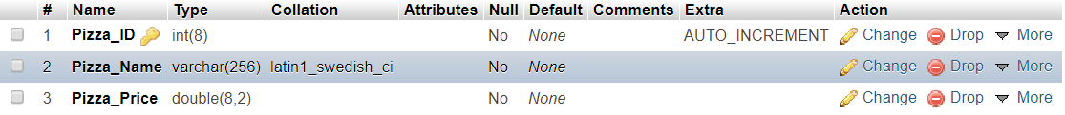***Figure 2.1***

***Figure 2.2***

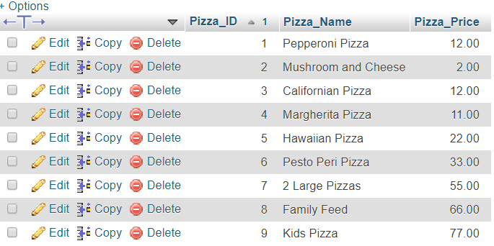

The Pizza’s table store the following:

* **Pizza_ID:** Each pizza stored in the table has a corresponding ID Number to uniquely identify the Pizza if necessary. The pizza ID is stored as an auto incrementing integer with a maximum length of 8 numbers.
* **Pizza_Name:** Each pizza name will be stored. This will be used in the update query in the admin page if the pizza price needs to be updated. The pizza name is stored as a VARCHAR (String) of a maximum length of 256 characters.
* **Pizza_Price:** Each Pizza has a corresponding price. The price in the admin page can be updated. If the price is updated, then the price on the site retrieves this value and is updated automatically. The pizza price is stored as a double which is a maximum of 8 characters and will be rounded to 2 decimal places.

## Orders Table:

The orders table is used to store the orders submitted by each customer. Once a customer submits a valid order, their order is sent automatically to this database.

***Figure 3.1:***

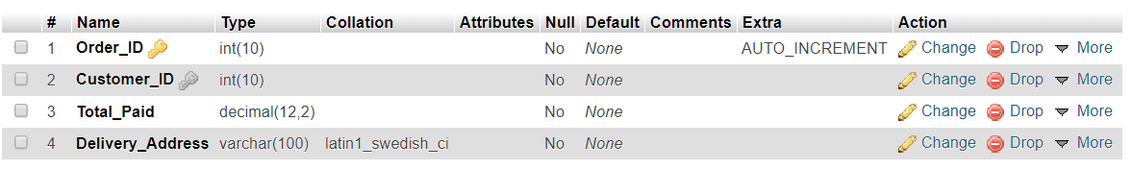

***Figure 3.2:***

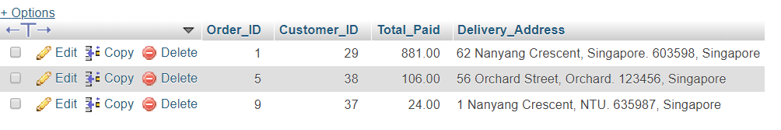

The order table shows the following:

* **Order_ID:** Each order has an order ID that is the primary key. This can be used to uniquely identify the order. The order ID is stored as an auto incrementing integer variable with a maximum length of 10 digits.
* **Customer_ID:** The Customer ID is a foreign key in the orders ID table. It references the customer ID in the customers table. Like the customers table, the Customer ID is stored as an integer variable with a maximum length of 10 digits.
* **Total_Paid:** The total paid is the amount of the customer’s order. The Total Paid field is stored as a decimal data type which is a maximum length of 12 digits and rounded of to 2 decimal places.
* **Delivery_Address:** The delivery address is the address that it is obtained from the customers account.This is obtained from signup/login. It is stored as a VARCHAR (String) of maximum length of 100 characters. It is a concatenation of the Unit/Apt Number, Street Name, Suburb and 6-digit postcode.

# Web Application Design Tests:

## Homepage Tests

|  |  |
| --- | --- |
| **Test** | **Pass/Fail Test** |
| 1. Home page successfully displays wide banner in top half of screen and smaller banners as the user scrolls down. | Test Passed |
| 1. When the clicks on each navigation item, they are redirected to the correct corresponding page. The home icon should stay on the same page but refresh the page. | 5/5 Tests Passed |
| 1. When the user hovers over the Sign up/Login page, the user will see a drop-down list containing 4 items. | 4/4 Tests Passed |
| 1. After scrolling to the bottom of the home page, the user should see a footer below the banners. | Test Passed |
| 1. If user is logged in, then their name is displayed | Test Passed |

## Sign up/Login Tests

|  |  |
| --- | --- |
| **Test** | **Pass/Fail Test** |
| 1. When page is displayed, user should see both a login and sign up form. | Test Passed |
| 1. User is required to fill in all forms in either sign up or login before being able to submit. | Test Passed |
| 1. Once the user signs up, then their data is added to the database. | Test Passed |
| 1. Upon submission of password in sign up field, the user’s password is hashed out so it cannot be seen in the database. | Test Passed |
| 1. Full Name requires 2 words minimum. | Test Passed |
| 1. Email address must contain “@” and “.”symbols and is validated by HTML5. | Test Passed |
| 1. Password entered throws alert error if it does not contain at least 1 capital letter and a minimum of 8 characters. | Test Passed |
| 1. Date of Birth entered throws alert error if date is not in the past. | Test Passed |
| 1. Unit/Apt No must be an integer value. | Test Passed |
| 1. Street Name must be at least one word with letters only. | Test Passed |
| 1. Suburb must be a string of letters only. | Test Passed |
| 1. Postcode must be an integer of exactly 6 numbers. | Test Passed |
| 1. Upon clicking Login, the user’s data is validated against the database. If their record does not exist, then they’re redirected to the same page. | Test Passed |
| 1. Once the user selects “Create Account”, and all data has been validated to be true, then their record is added to the database. | Test Passed |
| 1. Upon resizing the page, the form fields can still be accessed. | Test Passed |

|  |  |
| --- | --- |
| **Test** | **Pass/Fail Test** |
| 1. The users name is displayed in the top left corner box of the menu page if they’re logged in successfully. | Test Passed |
| 1. 3 Pizza images are displayed with their corresponding text and price from the database. A textbox for the user to enter the quantity is also included. | Test Passed. |
| 1. An add icon is displayed for each item. | Test Passed |
| 1. If the add item is clicked, then the user’s item is added to the table on the left-hand side. | Test Passed |
| 1. When the user hovers over the menu navigation bar (NTU Classics | Student Specials), then the corresponding item is highlighted. | Test Passed |
| 1. The “Go to Cart” button redirects the user to the NTU Classics page if there are no items in the cart and displays an alert error. | Test Passed |
| 1. The “Go to cart” button redirects the user to login/signup page if they are not found to be logged in. | Test Passed |
| 1. If both the user is logged in and they have successfully added items to their cart, then they are able to successfully view their cart. | Test Passed |
| 1. Items are successfully added to cart. | Test Passed |
| 1. Item prices are successfully updated if the admin price is submitted. | Test Passed |
| 1. Alert the user if an entry is less than 0. | Test Passed |

## Menu and Promotions: (NTU Classics, Student Specials, Our Deals, Absolute Steals)

## Locate Us:

|  |  |
| --- | --- |
| **Test** | **Pass/Fail Test** |
| 1. The users name is displayed in the top left corner box of the menu page if they’re logged in successfully. | Test Passed |
| 1. The opening hours, delivery hours, pizzeria address and contact number and email address are displayed. | Test Passed |
| 1. A map of where the user can find the pizzeria is displayed. | Test Passed |

## Review Us:

|  |  |
| --- | --- |
| **Test** | **Pass/Fail Test** |
| 1. If any field in the review page is not filled in, then alert the user before proceeding | Test Passed |
| 1. On entry, check that the user has entered a valid address syntactically. The email must contain the “@” and “.” Symbols to be a valid email. | Test Passed |
| 1. Upon submission, the user (web server address) will receive an email saying their review has been received by the NTU Pizzeria | Test Passed |

## Cart Controller:

|  |  |
| --- | --- |
| **Test** | **Pass/Fail Test** |
| 1. All items that were added in the menu page by the user appear in the menu page. | Test Passed |
| 1. All quantities entered by the user should be accumulated in the cart if multiple entries exist and data should be correct. | Test Passed |
| 1. Price should be accumulated based on each subtotal. | Test Passed |

## Delivery Review:

|  |  |
| --- | --- |
| **Test** | **Pass/Fail Test** |
| 1. No entries are left as empty or invalid. | Test Passed |
| 1. Entries should correspond to the user’s profile | Test Passed |
| 1. Date generated is the current date/time. | Test Passed |

# Implementation:

## Coding of the Web Page Templates:

Each web page in my site has a common header section with the only item aspect differing is the name written on each button and whether it includes a secondary navigation bar for the menu. To split these, I have created 3 header files. The first is any page where the button’s text is “Order Now.” This is implemented on the pages that do not display food items such as the home, locate, sign up/login and review page. This file is called “headerOrderNow.php.” The second template is used for the menu items (Promotions excluded). Although both the menu and promotions page both contain headers that lead to the cart controller, they both contain secondary navigation bars with links to different pages. This file is called “menuheader.php.” The final template is to account for the promotions page. It contains different links in the secondary navigation bar to that of the menu page. This file is called “promotionsheader.php.” The list below contains corresponding links to the code in the appendices.

* headerOrderNow.php
* menuheader.php
* promotionsheader.php

## Coding of Each Web Page:

Each web page in my site is linked to the common CSS page “index.css.” This file incorporates the common stylings amongst all web pages such as background image and positioning of header items. Each page has at least the common CSS (“index.css”) and a corresponding CSS page of its own.

* index.php: The home page of the site. Contains banners to various promotions offered by the pizzeria. Links to the other pages using a navigation bar.
* admin.php: This is the page which can be used to update prices. I have made this page accessible using the top corner menu bar. It contains a table which allows the admin to update the prices in the site. Links to the index.css and admin.css
* cartController.php: Displays a table in php of all the items that the user has added to the cart. The user, on this page, is also able to enter any customisations for their order. Links to the index.css and cartcss.css
* deliveryconfirmation.php: Takes the users information from their account and displays it back to them to confirm their details for order delivery. Once this has been confirmed, the order is sent to the database and the user receives an email regarding the status of their order. Links to index.css and delivery.css
* locateus.php: contains a map of where the pizzeria is located as well as the contact and address details of the pizzeria. Links to index.css and locate.css
* ntuclassics.php: is the first menu of the site. It is a category of the range of items offered by the pizzeria. The user can add items from this menu to the cart by clicking on the add button. This page utilizes index.css and menucss.css which is a common CSS file used for other menu files throughout the site. In order to validate the menu items and ensure they can be added to cart, menucart.js is linked to this page.
* promotions.php: is the first promotions page displayed to the user when the “Promotions” link is clicked on. This works the same as the menu as it displays items that the user can view and add to cart. This page is linked to the index.css and menucss.css files as the promotions page is also a menu. To validate it, the menucart.js file is used.
* promotions2.php: is the second promotions page which is displayed when the user clicks on “Absolute steals” in the secondary navigation bar of the site. This page links to index.css, menucss.css, studentspecialsCSS.css and menucart.js. The student specials CSS file is included because like the student specials menu, the promotions2 file is the second item in the navigation bar.
* review.php: allows the user to enter a review of their order and submit it to the pizzeria. The review page contains a form in which all fields are validated and required to be filled out. The page links to index.css and reviewCSS.css.
* signupLogin.php: Allows the user to either create an account or login to an existing account. Once the user creates an account, their information is stored in the database. This page links to index.css, signin.css and validates the form fields using signupvalidator.js.
* studentspecials.php: is the second menu in the site. It can be navigated to by clicking on the link in the navigation bar of ntuclassics.php. It is another menu and allows the user to add and view their cart. This page utilizes index.css, menucss.css, studentspecialsCSS.css and validates the quantities using menucart.js.

## Coding of Each Function:

* confirmdelivery.php: is called upon delivery confirmation. It adds the users order the database, resets the cart items so the cart items are removed for the users next order, mails the user for confirmation and redirects the user to the home page.
* confirmreview.php: emails the user that their review has been received.
* create_user.php: After the user fills out the form, this function gets the users data and creates an account by storing their data in the database. It is also stored in a session variable so their name can be displayed throughout the site.
* CreateTable.php: is not implemented throughout the program, however the MYSQL codes were the codes used initially to create the tables and insert their associated initial data.
* login.php: After the user decides to login, this function gets their inputted details and validates it against the database. If a record exists, then they will be taken to the home page in which their name is displayed. If it is not valid, the page will be refreshed, and they will try again.
* logout.php: Unset all the session variables relating to user login and redirects the user to the sign up/login page.
* menucart.js: validates that before the qty is added to the cart, that the qty is not 0. If it is, then alerts the user that the quantity is empty. Secondly, if the quantity is valid, this file contains function which adds each item to the table on each menu page using an event listener.
* ntuclassicscart.php, promotionscart.php, promotions2cart.php, studentspecialscart.php: Checks that each menu item the user has decided to add exists and then stores them in an associated session array which is then displayed in the cart.
* signupvalidator.js: each function in this file validates a text field in the sign up/login page. If all required fields are valid then the user can continue throughout the site. If they are not, then the function is used to display an error message.
* updateNTUClassics.php, updatePromotions.php, updatepromotions2.php, updatestudentspecials.php: The functions in these 4 php files are used to update the database when the prices are modified in the admin page. This data is then used to update the prices in the menu.
* validateReview.js: validates all fields in the review form are filled out correctly before the user is emailed and redirected to the home page.

# Testing of Web Application:

## Signup/Login Test

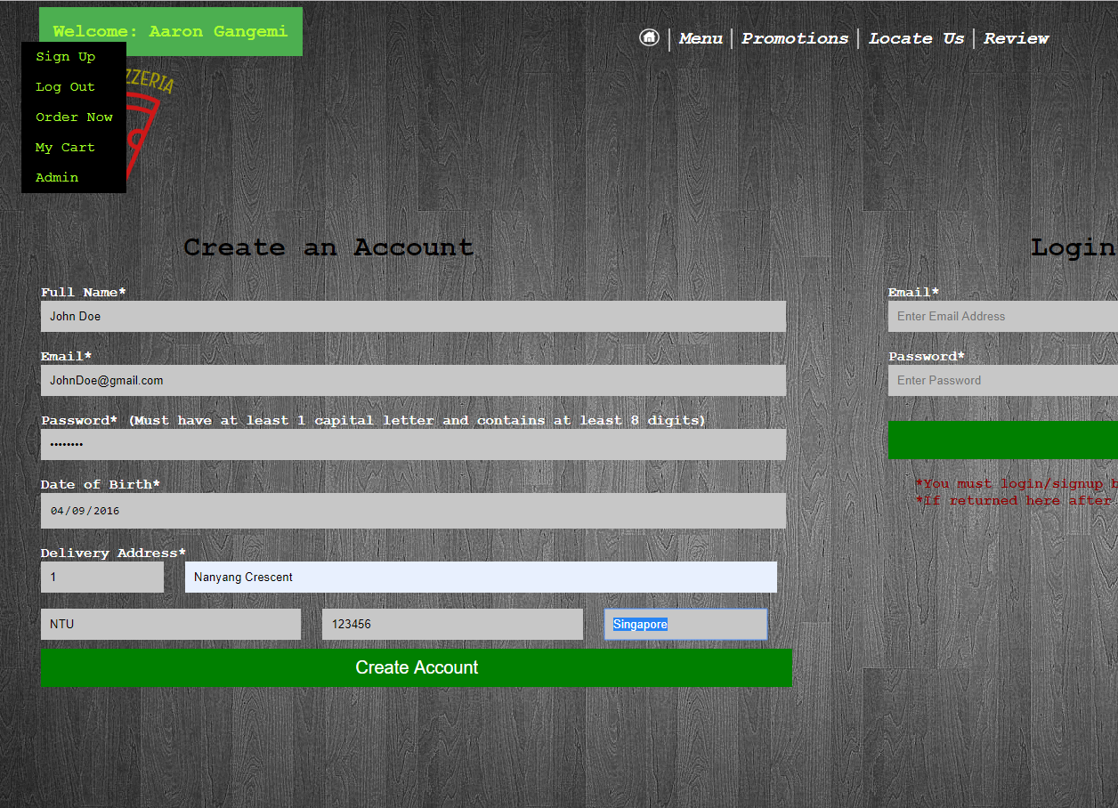

The sign-up page in the above example contains all fields entered with valid data. Upon the user clicking submit. The following happens.



The new entry has been added successfully to the database.

The user details are then stored in a SESSION variable

In addition to this, the users name is displayed throughout the site in the top left-hand corner.

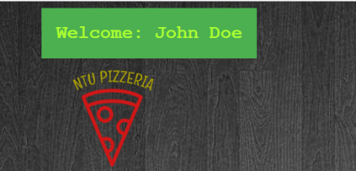

The test has passed successfully as the name has been retrieved from the SESSION variable and was successfully stored in the database

If the user was to be unsuccessful due to a field not being entered, HTML should show an error message as follows. In addition, If the date is in the past, an error as should also be shown.

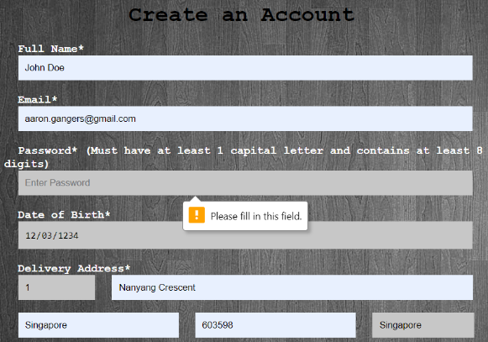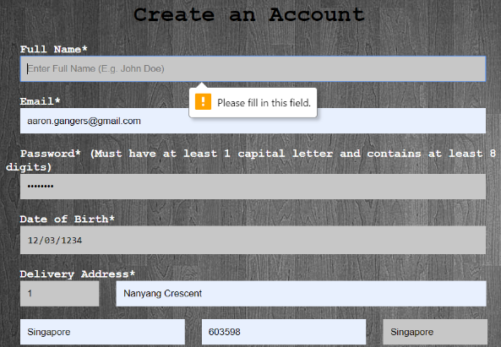

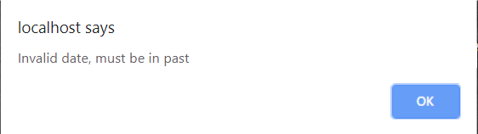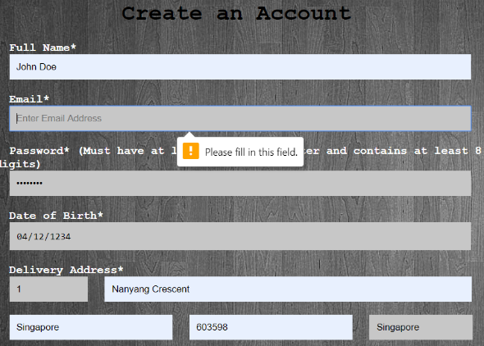

Given the above error messages are the results of invalid form, this test is a success.

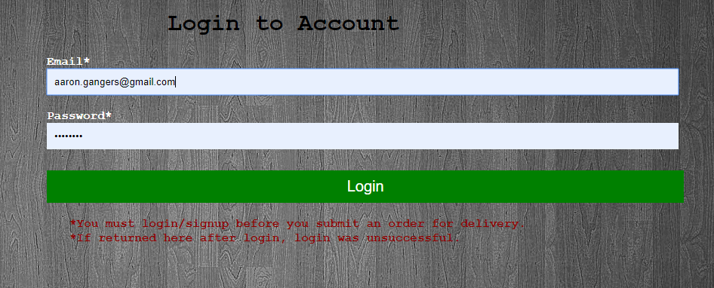

The fields entered in the login above are already registered in the database. After clicking login, the following is displayed.



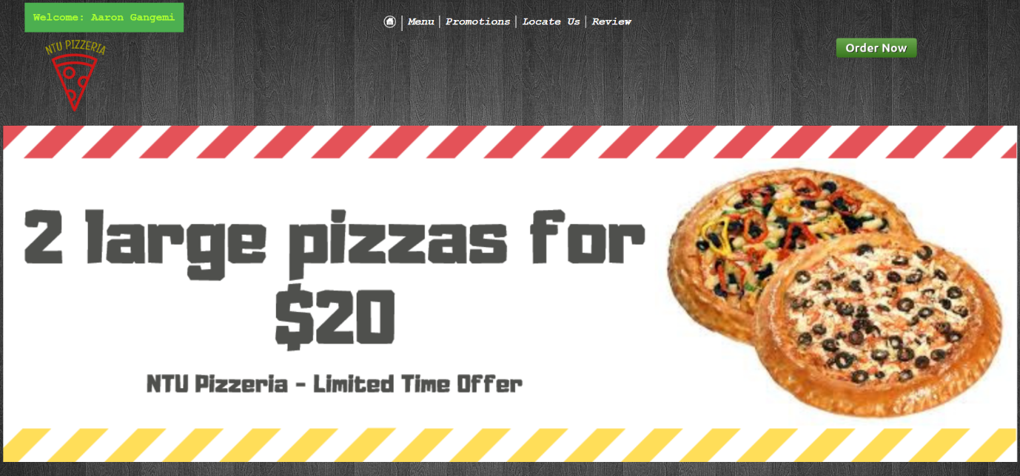

As we can see in the top left corner, the name was successfully updated to the name in the database. Therefore, login was successful.

## Menu and Promotions Page Test

The following tests are in place for the promotions and menu page,

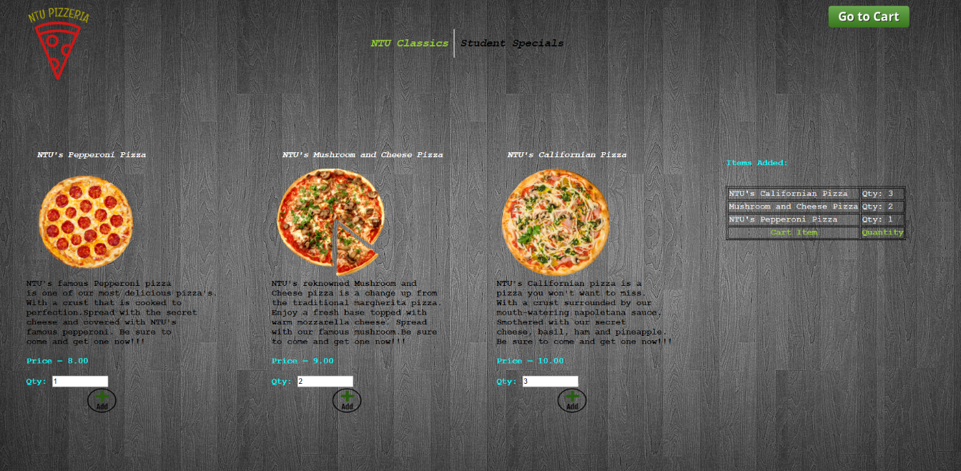Now the user navigates their way to the menu by clicking on “Menu” in the navigation bar. They enter their desired quantities as follows:

The menu page after entering valid quantities was successful as the user entered positive integers and the items added table to the right of the page was updated.

However, if the user was to enter an invalid quantity, HTML would display the following error:

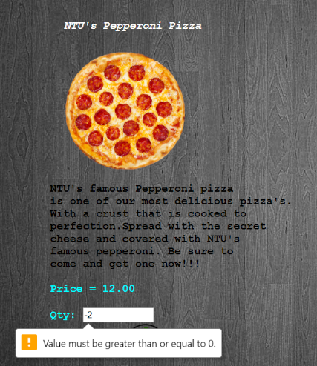

Now we need to test if the cart is empty and the user wishes to proceed to cart. If this happens, the following is displayed:

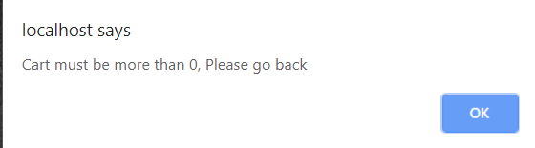

As we can see, if the cart is empty, then the user is not able to proceed and is redirected back to the first menu, hence making this test a success.

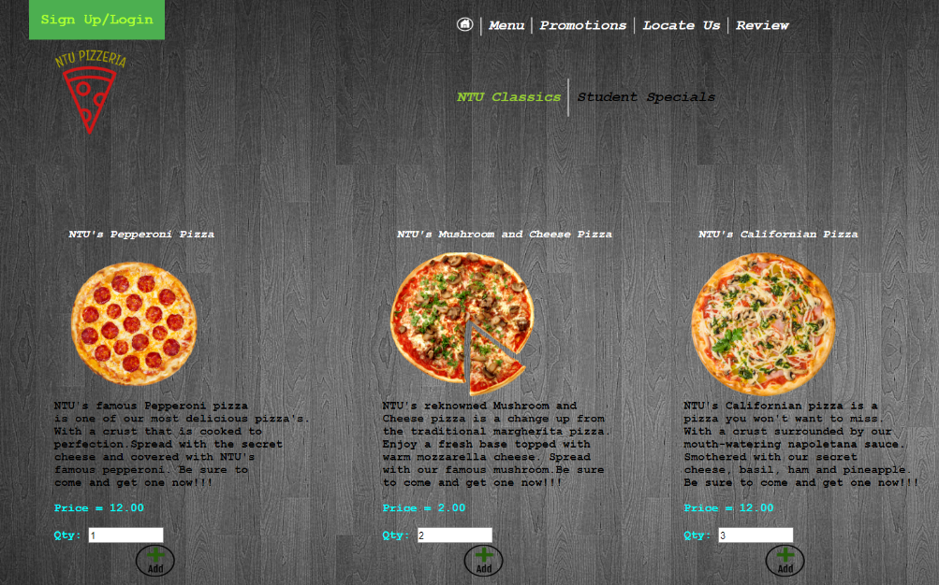In addition, the final test on this page we must run is if the user is not logged in and attempts to submit an order. The below image is the menu page, however, notice that the user is now logged out.

If the user clicks “Go to Cart”, the following is displayed.

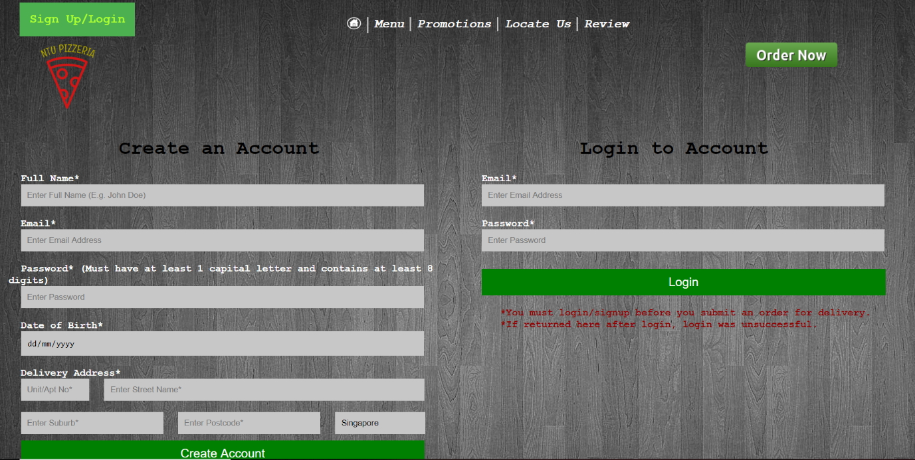

As we can see, the user was redirected to the sign-up/login page, making this test a success.

## Cart Controller Test:

The next test is that if all data is inputted and deemed as valid, then all items should be displayed in the cart controlling page. This page also allows the user to ask for any customisations to their pizza using a scrolling text box.

The following results occurs once the user clicks on “Go to Cart.”

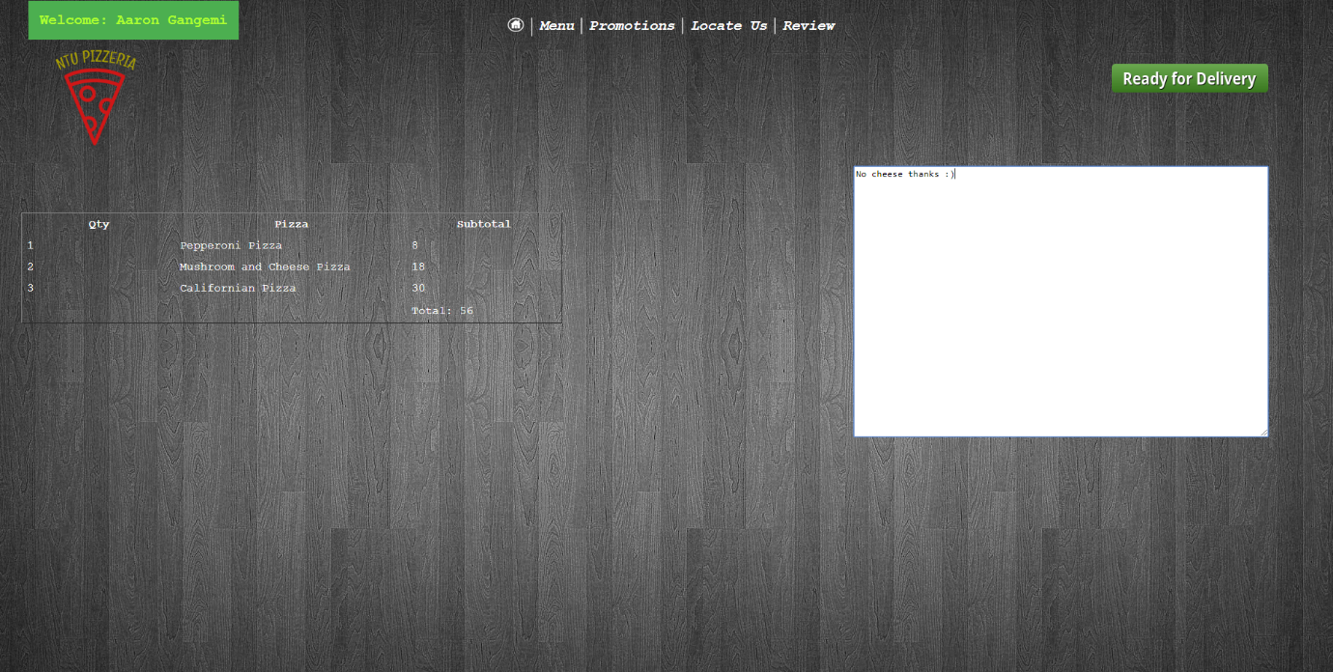

As we can see the items are successfully displayed and the user wishes to ask the pizzeria for no cheese on his pizza. Therefore, the above test is a pass.

## Delivery Confirmation Tests:

As we know, the user will not be able to proceed to this page if they are not logged in, as we tested for that on the menu page.

Furthermore, if the user enters a customisation, the entry should appear in the delivery confirmation along with the customer’s account details and the current date and time. The following results appear:

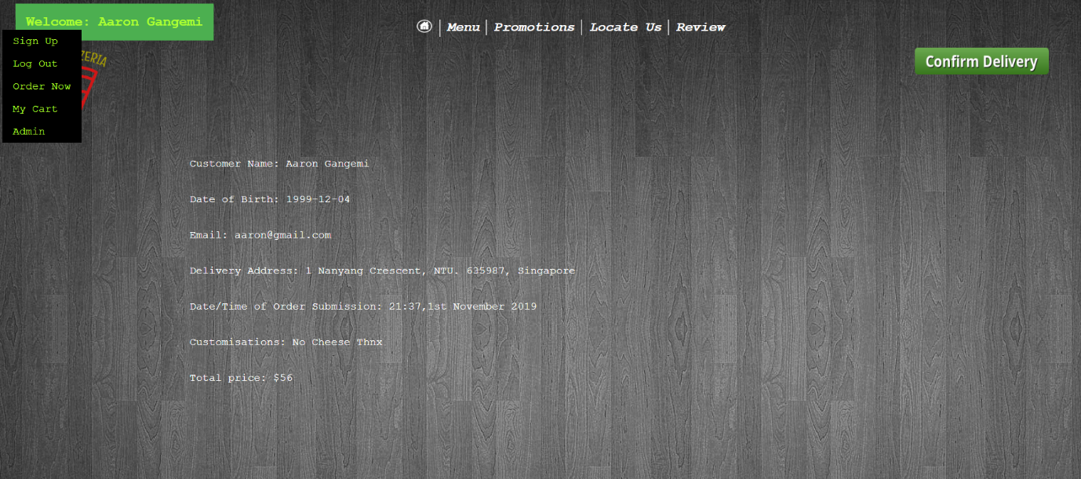

Given we see this page associated with the users account and order details, the following test was a success.

The next test following this, is that the user should receive an email stating that their order is being prepared. If this is shown, then the test is a success. We see the following results:

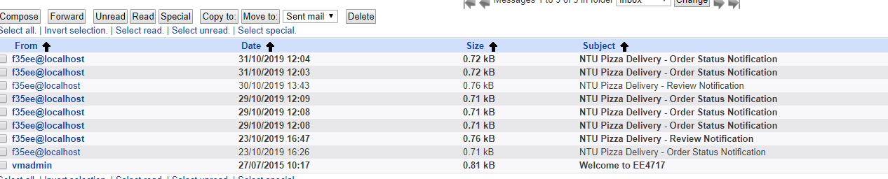

This is an email in the server which clearly shows an email was sent and the above test has passed.

## Locate Us:

The only tests we can run for these pages are to ensure that the pages can be displayed with the logged in username and the map and details appearing. The following results appear after clicking on “Locate Us” from any page’s menu bar.

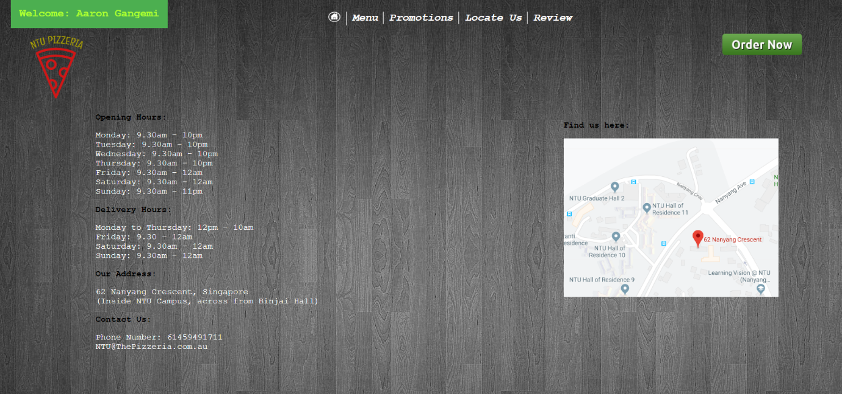

Given that the Locate us page appears with the associated images and buttons, this means that the test was a success.

## Review Us Test:

The review us page contains a list of forms in which the user must fill out to review the pizzeria. First, we check the user has entered a valid name and email address. All fields are required to be filled in.

The following errors appear if the user leaves a field empty:

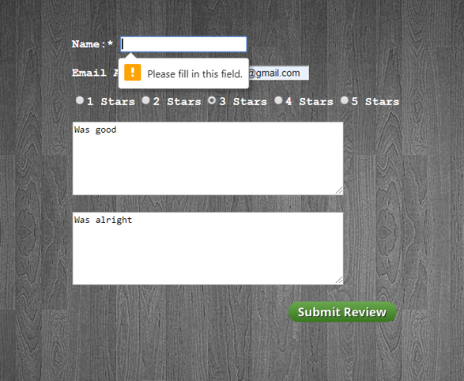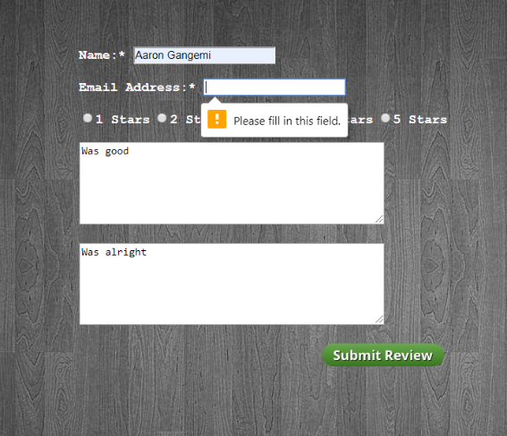

Given these alerts appear, this means that the test was a success.

Secondly, we must check that when an email is not syntactically correct, an error is displayed.

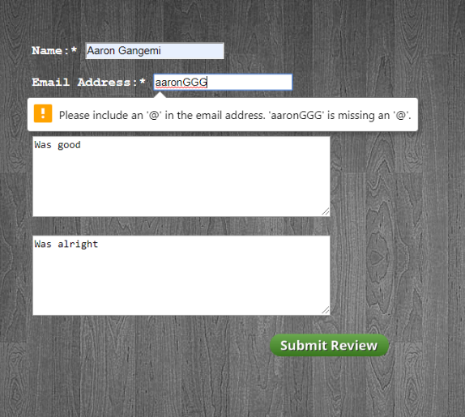

Given we receive this message, the above test was a success.

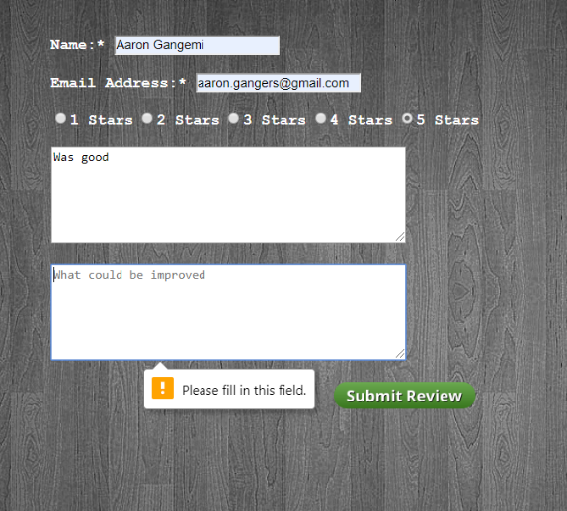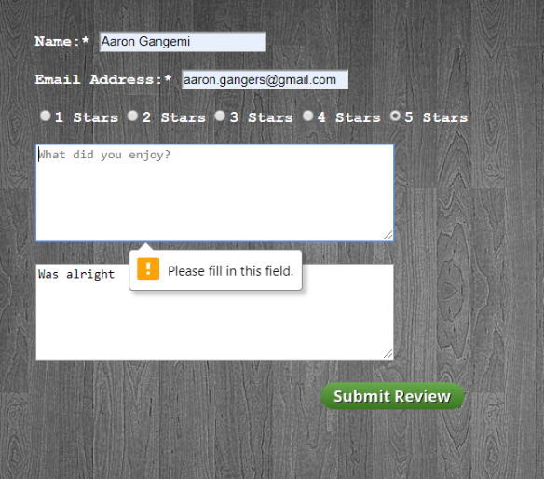Then we must check that if the user does not enter text on what could be improved and what they like, an error alert must appear to notify the user that a field is required to be filled in.

Given we receive this message, the above test was a success.

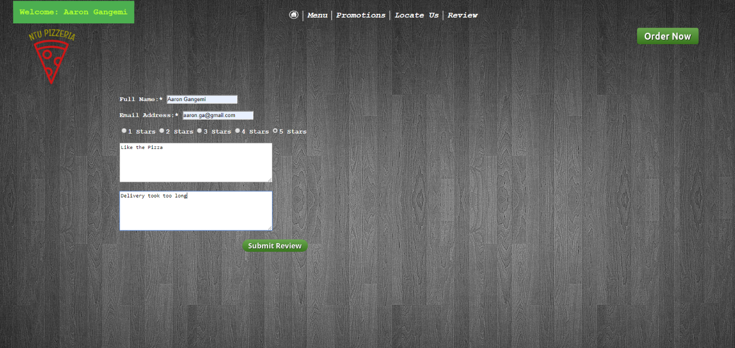

Finally, if all fields are deemed as valid like above, the user should receive an email stating that the NTU Pizzeria has received their review.

The following appears in the server’s mail account:



This is an email stating the review notification has been received. Therefore, the above test is a pass and the review page is successful.

# Conclusion:

## What has been achieved?

I have developed a website that allows users to successfully order a pizza online. The website successfully follows its intended design to ensure that customers can make an order as quickly and as simple as possible. The customer is provided with a range of pizza’s and promotions to choose from. In addition, if the owner wishes to update the price for future reference, an admin page has also been incorporated which is linked to the database. This will update prices automatically.

## What has been deferred?

I have deferred the payment system in this site. I have stated that the payment system should occur straight after delivery confirmation. The user, from there, would be redirected to the home page. Furthermore, I have deferred the deletion from cart. The user is able to add a pizza but no delete a pizza as of yet.

# Appendices:

# Appendix: Source Codes:

## Coding of Page Templates:

### headerOrderNow.php

<ul class = "navigationbar">

                <li class="navitem"><strong><a href = "index.php"><img src = "images/homeIcon.png" width = "23px" height="20px"></a></strong></li>

                <li class="navitem"><strong><a href = "ntuclassics.php">Menu</a></strong></li>

                <li class="navitem"><strong><a href = "promotions.php">Promotions</a></strong></li>

                <li class="navitem"><strong><a href = "locateus.php">Locate Us</a></strong></li>

                <li><strong><a href = "review.php">Review</a></strong></li>

            </ul>

            <div>

                <div class = "dropdown">

                 <strong><a id = "signuplabel" class = "droptxt" href="signUpLogin.php"><?php if(!isset($_SESSION)){session_start();}if(!isset($_SESSION['loggedinUser']['fullname'])){echo "Sign Up/Login";}else{echo "Welcome: ".$_SESSION['loggedinUser']['fullname'];}?></a></strong>

                 <div class = "dropdown-content">

                     <a href="signUpLogin.php">Sign Up</a>

                     <a href="logout.php"><?php if(!isset($_SESSION['loggedinUser'])){echo "Log In";}else{ echo "Log Out";}?></a>

                     <a href="ntuclassics.php">Order Now</a>

                     <a href="cartController.php">My Cart</a>

                     <a href="admin.php">Admin</a>

                </div>

            </div>

                 <a id = "ordernowlabel" href="ntuclassics.php"><img src = "images/ordernow.png" width = 150px height = 40px></a>

            </div>

            <div>

               <br><img class = "companyLogo" src = "images/logo.png" alt = "NTU Pizzeria" width = "100px" height="10px">

            </div>

### menuheader.php

<nav>

            <ul class = "navigationbar">

                <li class="navitem"><strong><a href = "index.php"><img src = "images/homeIcon.png"

width = "23px" height="20px"></a></strong></li>

                <li class="navitem"><strong><a href = "ntuclassics.php">Menu</a></strong></li>

                <li class="navitem"><strong><a href = "promotions.php">Promotions</a></strong></li>

                <li class="navitem"><strong><a href = "locateus.php">Locate Us</a></strong></li>

                <li><strong><a href = "review.php">Review</a></strong></li>

            </ul>

        </nav>

        <div>

                <div class = "dropdown">

                 <strong><a id = "signuplabel" class = "droptxt" href="signUpLogin.php">

<?php if(!isset($_SESSION)){session_start();}

if(!isset($_SESSION['loggedinUser']['fullname'])){echo "Sign Up/Login";}

else{echo "Welcome: ".$_SESSION['loggedinUser']['fullname'];}?></a></strong>

                 <div class = "dropdown-content">

                     <a href="signUpLogin.php">Sign Up</a>

                     <a href="logout.php"><?php

if(!isset($_SESSION['loggedinUser'])){echo "Log In";}else{ echo "Log Out";}?></a>

                     <a href="ntuclassics.php">Order Now</a>

                     <a href="cartController.php">My Cart</a>

                     <a href="admin.php">Admin</a>

                </div>

            </div>

                  <form id = "ordernowlabel" action = "ntuclassicscart.php" method="POST">

<input type = "image" id = "cartbutton" src = "images/button_go-to-cart.png" alt = "cartbutton" width = "150px" height="40px">

            </div>

            <div>

               <br><img class = "companyLogo" src = "images/logo.png" alt = "NTU Pizzeria"

width = "100px" height="120px">

            </div>

            <div class = "container">

                    <nav>

                    <ul class = "menunavigationbar">

                        <li class="menunavitem"><strong><a id = "menunavitem"

href = "ntuclassics.php">NTU Classics</a></strong></li>

                        <li class="menunavitem"><strong><a id = "menuitemnoborder"

 href = "studentspecials.php">Student Specials</a></strong></li>

                    </ul>

                    </nav>

                </div>

### promotionsheader.php

<nav>

            <ul class = "navigationbar">

                <li class="navitem"><strong><a href = "index.php"><img src = "images/homeIcon.png"

width = "23px" height="20px"></a></strong></li>

                <li class="navitem"><strong><a href = "ntuclassics.php">Menu</a></strong></li>

                <li class="navitem"><strong><a href = "promotions.php">Promotions</a></strong></li>

                <li class="navitem"><strong><a href = "locateus.php">Locate Us</a></strong></li>

                <li><strong><a href = "review.php">Review</a></strong></li>

            </ul>

        </nav>

        <div>

                <div class = "dropdown">

                 <strong><a id = "signuplabel" class = "droptxt" href="signUpLogin.php"><?php

if(!isset($_SESSION)){session_start();}

if(!isset($_SESSION['loggedinUser']['fullname'])){echo "Sign Up/Login";}

else{echo "Welcome: ".$_SESSION['loggedinUser']['fullname'];}?></a></strong>

                 <div class = "dropdown-content">

                     <a href="signUpLogin.php">Sign Up</a>

                     <a href="logout.php"><?php

if(!isset($_SESSION['loggedinUser'])){echo "Log In";}else{ echo "Log Out";}?></a>

                     <a href="ntuclassics.php">Order Now</a>

                     <a href="cartController.php">My Cart</a>

                     <a href="admin.php">Admin</a>

                </div>

            </div>

                  <form id = "ordernowlabel" action = "promotionscart.php" method="POST">

<input type = "image" id = "cartbutton" src = "images/button_go-to-cart.png"

alt = "cartbutton" width = "150px" height="40px">

            </div>

            <div>

               <br><img class = "companyLogo" src = "images/logo.png" alt = "NTU Pizzeria"

width = "100px" height="120px">

            </div>

            <div class = "container">

                    <nav>

                    <ul class = "menunavigationbar">

                        <li class="menunavitem"><strong><a id = "menunavitem"

 href = "promotions.php">Our Deals</a></strong></li>

                        <li class="menunavitem"><strong><a id = "menuitemnoborder"

 href = "promotions2.php">Absolute Steals</a></strong></li>

                    </ul>

                    </nav>

                </div>

Coding of Each Webpage

### index.php

<!DOCTYPE html>

<html lang="en">

<head>

<meta charset="utf-8">

<title>NTU Pizzeria - Home Page</title>

<link rel="stylesheet" href="index.css">

<link rel="Stylesheet" href="homepage.css">

</head>

<body>

    <header>

        <?php

        include 'headerOrderNow.php';

        ?>

    </header>

    <div id = "scrolltop">

        <a href = "promotions.php"><img id = "mainBanner" src="images/PizzaBanner1.png"

 alt="PizzaBanner" width="1920px" height="550px"></a>

    </div>

    <div id = "scrollbottom">

    <div>

        <a href = "promotions.php"> <img id = "familybanner" src = "images/familyfeedbanner.PNG"

alt = "family banner" width = "500px" height="350px"></a>

        <a href = "promotions.php"> <img id = "kidsbanner" src = "images/kidsbanner.PNG"

alt = "kidsbanner" width = "500" height = "350px"></a>

        </div>

    </div>

</body>

</html>

### ntuclassics.php

<!DOCTYPE html>

<html lang="en">

<head>

<meta charset="utf-8">

<title>NTU Pizzeria - NTU Classics</title>

<link rel="stylesheet" href="index.css">

<link rel="stylesheet" href="menucss.css">

<script type="text/javascript" src="cartJS.js"></script>

<script type="text/javascript" src="menucart.js"></script>

</head>

<body>

    <?php

    if(!isset($_SESSION))

    {

        session_start();

    }

    if(!isset($_SESSION['noOfItems']))

    {

        $_SESSION['noOfItems'] = 0;

    }

    $user = 'f35ee';

    $passwordLogin = 'f35ee';

    $database = "f35ee";

    $db = new mysqli('localhost', $user, $passwordLogin, $database);

    if(mysqli_connect_errno())

    {

        echo "Error: Could not connect to database, please try again later";

    }

    $query = "SELECT Pizza_price FROM Pizzas";

    $result = $db->query($query);

    if ($result) {

    for($i = 0; $i < $result->num_rows; $i++)

    {

        $row = $result->fetch_assoc();

        $_SESSION['prices'][$i] = $row['Pizza_price'];

    }

    }

    $db->close();

    ?>

    <header>

        <?php

        include 'menuheader.php';

        ?>

    </header>

    <div class="row">

        <div class = "column">

        <strong><em><label id = "pizzatitle" >NTU's Pepperoni Pizza</label></em></strong>

        <strong><p id = "pepperoniPizzaText"><img id = "pepperoniPizza"

src = "images/Pepperoni-Pizza.png" alt = "Pepperoni pizza image" width = "200" height="200">

        <br>NTU's famous Pepperoni pizza<br> is one of our most delicious pizza's.

          <br>With a crust that is cooked to<br> perfection.Spread with

           the secret<br> cheese and covered with NTU's<br>

            famous pepperoni. Be sure to <br>come and get one now!!!<br><br>

            <label id = "price" name = "peppprice"><?php echo "Price = ".$_SESSION['prices'][0];?>

</label><br><br>

            <label id = "price">Qty: </label><input id = "peppqtytextbox" class="qty"

name = "pepperoniQty" type = "number" min="0"><br>

            <img class = "addicon" id = "add1" src = "images/addicon.png" alt = "add icon here"

width = "60px" height="50px" onclick="addPepperoniToCart()"><br>

            </p></strong>

            </div>

        </div>

        <div class="row">

                <div class = "column">

           <strong><em><label id = "pizzatitle" >NTU's Mushroom and Cheese Pizza</label></em></strong>

            <strong><p id = "pepperoniPizzaText"><img id = "pepperoniPizza"

src = "images/mushroomcheese.png" alt = "Mushroom and Cheese pizza image" width = "200" height="200">

            <br>NTU's reknowned Mushroom and<br> Cheese pizza is a

            change up from<br> the traditional margherita pizza. <br>Enjoy a fresh base

            topped with<br> warm mozzarella cheese. Spread<br> with

               our famous mushroom.Be sure<br> to come and get one now!!!<br><br>

               <label id = "price" name = "mushprice"><?php echo "Price = ".$_SESSION['prices'][1];?>

</label><br><br>

               <label id = "price">Qty: </label><input id = "mushqtytextbox" class="qty"

 name = "mushcheeseQty" type = "number" min="0" id = "mushcheeseQty"><br>

               <img class = "addicon" id = "add2" src = "images/addicon.png" alt = "add icon here"

 width = "60px" height="50px" onclick="addMushroomToCart()"><br>

                </p></strong>

                </div>

            </div>

        <div class="row">

                <div class = "column">

            <strong><em><label id = "pizzatitle" >NTU's Californian Pizza</label></em></strong>

            <strong><p id = "pepperoniPizzaText"><img id = "pepperoniPizza"

src = "images/californianpizza.png" alt = "Californian pizza image" width = "200" height="200">

            <br>NTU's Californian pizza is a<br> pizza you won't want to miss.

             <br>With a crust surrounded by our<br> mouth-watering napoletana sauce.<br>

             Smothered with our secret<br> cheese, basil, ham and pineapple.<br>

             Be sure to come and get one now!!!<br><br>

            <label id = "price" name = "calprice"><?php echo "Price = ".$_SESSION['prices'][2];?>

</label><br><br>

            <label id = "price">Qty: </label><input id = "calqtytextbox" name = "californianQty"

class="qty" type = "number" min="0" id = "californianQty"></form><br>

            <img class = "addicon" id = "add3" src = "images/addicon.png" alt = "add icon here"

width = "60px" height="50px" onclick="addCalifornianToCart()"><br>

                </p></strong><br><br>

                </div>

            </div>

            <div class = "row">

            <div class = "column">

                <b><p id = "tablelabel">Items Added:</p></b><br>

                <table id = "cartTable">

                        <tr>

                            <th>Cart Item</th>

                            <th>Quantity</th>

                        </tr>

                </table>

            </div>

        </div>

        <?php

            if(!isset($_SESSION['alertUser']))

            {

                 $_SESSION['alertUser'] = false;

            }

            if($_SESSION['alertUser'] == true)

            {

                echo "<script type='text/javascript'>

                alert('Cart must be more than 0, Please go back');

                </script>";

                $_SESSION['alertUser'] = false;

            }

        ?>

</body>

</html>

### studentspecials.php

<!DOCTYPE html>

<html lang="en">

<head>

<meta charset="utf-8">

<title>NTU Pizzeria - Student Specials</title>

<link rel="stylesheet" href="index.css">

<link rel="stylesheet" href="menucss.css">

<link rel="stylesheet" href="studentspecialsCSS.css">

<script type="text/javascript" src="menucart.js"></script>

</head>

<body>

    <?php

    if(!isset($_SESSION))

    {

        session_start();

    }

    $user = 'f35ee';

    $passwordLogin = 'f35ee';

    $database = "f35ee";

    $db = new mysqli('localhost', $user, $passwordLogin, $database);

    if(mysqli_connect_errno())

    {

        echo "Error: Could not connect to database, please try again later";

    }

    $query = "SELECT Pizza_price FROM Pizzas";

    $result = $db->query($query);

    if ($result) {

    for($i = 0; $i < $result->num_rows; $i++)

    {

        $row = $result->fetch_assoc();

        $_SESSION['prices'][$i] = $row['Pizza_price'];

    }

    }

    $db->close();

    ?>

    <header>

            <?php

                include 'menuheader.php';

            ?>

            <div class = "container">

                    <nav>

                    <ul class = "menunavigationbar">

                        <li class="menunavitem"><strong><a id = "ntuclassicstitle"

href = "ntuclassics.php">NTU Classics</a></strong></li>

                        <li class="menunavitem"><strong><a id = "studentspecialstitle"

href = "studentspecials.php">Student Specials</a></strong></li>

                    </ul>

                    </nav>

                </div>

    </header>

    <div class="row">

        <div class = "column">

        <strong><em><label id = "pizzatitle" >NTU's Margherita Pizza</label></em></strong>

        <strong><p id = "pepperoniPizzaText"><img id = "pepperoniPizza"

src = "images/margheritapizza.png" alt = "Pepperoni pizza image" width = "200" height="200">

        <br>NTU's famous Margherita pizza<br> is our cheesiest pizza.

          A cheesy<br> delight filled and topped with<br> tomatoes and to add

           extra flavour,<br> sprikled with basil. Be sure to try<br> this cheesy sensation.

         Be sure to <br>come and get one now!!!<br><br>

         <label id = "price"><?php echo "Price = ".$_SESSION['prices'][3];?></label><br><br>

         <label id = "price">Qty: </label><input id = "margqtytextbox" class="qty" type = "number"

min="0" name = "margheritaQty" id = "margheritaQty"><br>

            <img id = "image" class = "addicon" id = "add1" src = "images/addicon.png"

 alt = "add icon here" width = "60px" height="50px" onclick="addMargheritaToCart()"><br>

            </p></strong>

            </div>

        </div>

        <div class="row">

                <div class = "column">

            <strong><em><label id = "pizzatitle" >NTU's Hawaiian Pizza</label></em></strong>

            <strong><p id = "pepperoniPizzaText"><img id = "pepperoniPizza"

src = "images/hawaiianpizza.png" alt = "Pepperoni pizza image" width = "220" height="200">

            <br>Ham and Cheese not enough?<br> Why not add Pineapple?

            This pizza<br> is covered with fresh thick-

cut ham,<br> warm cheese and our famous crunchy<br> pineapple.

            Enjoy a fresh woodfired<br> base and that delicious crunch.<br>

 Be sure to come and get one now!!!<br><br>

            <label id = "price"><?php echo "Price = ".$_SESSION['prices'][4];?></label><br><br>

            <label id = "price">Qty: </label><input id = "hawqtytextbox" type = "number" min="0"

name = "hawaiianQty" class="qty" id = "hawaiianQty"><br>

                <img class = "addicon" src = "images/addicon.png" id = "add2" alt = "add icon here"

 width = "60px" height="50px" onclick="addHawaiianToCart()"><br>

                </p></strong>

                </div>

            </div>

        <div class="row">

                <div class = "column">

            <strong><em><label id = "pizzatitle" >NTU's Pesto Peri Chicken Pizza</label></em></strong>

            <strong><p id = "pepperoniPizzaText"><img id = "pepperoniPizza"

src = "images/pestoperichickenpizza.png" alt = "Pepperoni pizza image" width = "200" height="200">

            <br>NTU's Pesto Peri Chicken pizza<br> is a one of a kind.

             A base with<br> napoletana sauce replaced with<br> our divine pesto sauce.

             A mouth-<br>watering pizza, smothered with<br> chicken, ham, capsicum and olives.<br>

             Be sure to come and get one now!!!<br><br>

             <label id = "price"><?php echo "Price = ".$_SESSION['prices'][5];?></label><br><br>

             <label id = "price">Qty: </label></strong><input id = "pestoqtytextbox" type = "number"

 min="0" name = "pestoQty" class="qty" id = "pestoQty"></form><br>

                <img id = "image" class = "addicon" id = "add3" src = "images/addicon.png"

 alt = "add icon here" width = "60px" height="50px" onclick = "addPestoToCart()">

                </p>

                </div>

            </div>

            <div class = "row">

            <div class = "column">

                    <b><p id = "tablelabel">Items Added:</p></b><br>

                    <table id = "cartTable">

                        <tr>

                            <th>Cart Item</th>

                            <th>Quantity</th>

                        </tr>

                    </table>

            </div>

        </div>

        <?php

            if(!isset($_SESSION['alertUser']))

            {

                $_SESSION['alertUser'] = false;

            }

            if($_SESSION['alertUser'] == true)

            {

                echo "<script type='text/javascript'>

                alert('Cart must be more than 0, Please go back');

                </script>";

                $_SESSION['alertUser'] = false;

            }

        ?>

</body>

</html>

### locateus.php

<!DOCTYPE html>

<html lang="en">

<head>

<meta charset="utf-8">

<title>NTU Pizzeria - Locate Us</title>

<link rel="stylesheet" href="index.css">

<link rel="stylesheet" href="locate.css">

</head>

<body>

    <header>

    <?php

            include 'headerOrderNow.php';

            ?>

    </header>

    <div class = "location">

            <strong><p id = "locationtext">Find us here:</p></strong>

            <img id = "locationimage" src = "images/location.PNG" alt = "Our location"

width = "400px" height = "270px">

    </div>

    <div>

            <strong><label id = "hoursTitle">Opening Hours:</label></strong>

            <ul class = "hourslist">

                <li>Monday: 9.30am - 10pm</li>

                <li>Tuesday: 9.30am - 10pm</li>

                <li>Wednesday: 9.30am - 10pm</li>

                <li>Thursday: 9.30am - 10pm</li>

                <li>Friday: 9.30am - 12am</li>

                <li>Saturday: 9.30am - 12am</li>

                <li>Sunday: 9.30am - 11pm</li>

            </ul>

            <strong><label id = "hoursTitle">Delivery Hours:</label></strong>

            <ul class = "hourslist">

                <li>Monday to Thursday: 12pm - 10am</li>

                <li>Friday: 9.30 - 12am</li>

                <li>Saturday: 9.30am - 12am</li>

                <li>Sunday: 9.30am - 12am</li>

            </ul>

            <strong><label id = "addresstitle">Our Address:</label></strong>

            <p id = "addressdetails">62 Nanyang Crescent, Singapore<br>

(Inside NTU Campus, across from Binjai Hall)</p>

            <strong><label id = "addresstitle">Contact Us:</label></strong>

            <p id = "contactdetails">Phone Number: 61459491711<br>

               NTU@ThePizzeria.com.au</p>

        </div>

</body>

</html>

### review.php

<!DOCTYPE html>

<html lang="en">

<head>

<meta charset="utf-8">

<title>NTU Pizzeria - Review Page</title>

<link rel="stylesheet" href="index.css">

<link rel="stylesheet" href="reviewCSS.css">

<script type="text/javascript" src = "validateReview.js"></script>

</head>

<body>

    <header>

            <?php

            include 'headerOrderNow.php';

            ?>

    </header>

    <div id = "centreform">

    <form method="GET" action = "confirmreview.php" onsubmit="return validateReviewForm()">

        <strong><label>Name:* </label></strong><input type="text" name = "FullName"

id = "fullname" required><br><br>

        <strong><label>Email Address:* </label></strong><input type="email" name = "email address"

id = "emailaddress" required><br><br>

        <strong><label><input type = "radio" name = "radioStar" id = "1Star"/>1 Stars</label></strong>

        <strong><label><input type = "radio" name = "radioStar" id = "2Star"/>2 Stars</label></strong>

        <strong><label><input type = "radio" name = "radioStar" id = "3Star"/>3 Stars</label></strong>

        <strong><label><input type = "radio" name = "radioStar" id = "4Star"/>4 Stars</label></strong>

        <strong><label><input type = "radio" name = "radioStar" id = "5Star"/>5 Stars</label></strong><br><br>

        <textarea name = "enjoyedtextbox" id = "enjoyedtextbox" rows = "6" cols="50"

placeholder="What did you enjoy?" required></textarea><br><br>

        <textarea name = "improvedtextbox" id = "improvedtextbox" rows = 6 cols = "50"

 placeholder="What could be improved" required></textarea><br><br>

  <input id = "submitbutton" type = "image" src="images/button_submit-review.png" width="150"></form>

    </div>

</body>

</html>

### signUpLogin.php

<!DOCTYPE html>

<html lang="en">

<head>

<meta charset="utf-8">

<title>NTU Pizzeria - Sign Up/Login</title>

<link rel="stylesheet" href="index.css">

<link rel= "stylesheet" href= "signin.css">

<script type="text/javascript" src="signupvalidator.js"></script>

</head>

<body>

    <header>

            <?php

            include 'headerOrderNow.php';

            ?>

    </header>

    <div class="row">

        <div class="column" id = "signinbox">

            <form action="create_user.php" method = "POST" onsubmit=" return validateSignup()"

id = "frm1">

                <h1>Create an Account</h1>

                <label><b>Full Name*</b></label><br>

                <input type="text" placeholder="Enter Full Name (E.g. John Doe)" name = "fullname"

  id = "fullname" required><br><br>

                <label><b>Email*</b></label><br>

                <input type = "email" placeholder="Enter Email Address" name = "emailfield"

id = "email" required><br><br>

<label><b>Password* (Must have at least 1 capital letter and contains at least 8 digits)</b>

</label><br>

                <input type = "password" placeholder="Enter Password" name = "password"

id = "password" required><br><br>

                <label><b>Date of Birth*</b></label><br>

                <input type="date" placeholder="Enter D.O.B" name="dateofBirth" id = "dateofbirth"

required><br><br>

                <label><b>Delivery Address*</b></label><br>

                <input id = "housenumber" type = "number" placeholder="Unit/Apt No*"

name = "houseNumber" id = "houseNumber" min = "1" required>

                <input id = "streetname" type = "text" placeholder="Enter Street Name*"

name = "streetName" id = "streetText" required><br><br>

                <input id = "suburb" type = "text" placeholder="Enter Suburb*" name = "suburbName"

id = "suburbName" required/>

                <input id = "postcode" type = "number" placeholder="Enter Postcode*"

name ="postcode" id = "postcode" required/>

                <input id = "country" type = "text" value="Singapore" readonly>

                <input id = "createacntbtn" type = "submit" value="Create Account"></form>

        </div>

        <div class="column">

                <h1>Login to Account</h1>

                <form action="login.php" method = "POST" onsubmit="return validateLogin()">

                <label><b>Email*</b></label><br>

                <input type = "email" placeholder="Enter Email Address" name = "emailfieldLogin"

id = "email" required><br><br>

                <label><b>Password*</b></label><br>

                <input type = "password" placeholder="Enter Password" name = "passwordLogin"

id = "passwordLogin" required><br><br>

                <input id = "createacntbtn" type="submit" value="Login"><br><br>

      <b><strong><label id = "warning">*You must login/signup before you submit an order for delivery. <br></label></strong></b>

     <b><strong><label id = "warning">*If returned here after login, login was unsuccessful.

</label></strong></b>

                </form>

        </div>

    </div>

</body>

</html>

### promotions.php

<!DOCTYPE html>

<html lang="en">

<head>

<meta charset="utf-8">

<title>NTU Pizzeria - NTU Classics</title>

<link rel="stylesheet" href="index.css">

<link rel="stylesheet" href="menucss.css">

<script type="text/javascript" src="cartJS.js"></script>

<script type="text/javascript" src="menucart.js"></script>

</head>

<body>

<?php

    if(!isset($_SESSION))

    {

        session_start();

    }

    if(!isset($_SESSION['noOfItems']))

    {

        $_SESSION['noOfItems'] = 0;

    }

    $user = 'f35ee';

    $passwordLogin = 'f35ee';

    $database = "f35ee";

    $db = new mysqli('localhost', $user, $passwordLogin, $database);

    if(mysqli_connect_errno())

    {

        echo "Error: Could not connect to database, please try again later";

    }

    $query = "SELECT Pizza_price FROM Pizzas WHERE Pizza_Name = '2 Large Pizzas'";

    $result = $db->query($query);

    $row = $result->fetch_assoc();

    $_SESSION['prices']['2 Large Pizzas'] = $row['Pizza_price'];

    $query = "SELECT Pizza_price FROM Pizzas WHERE Pizza_Name = 'Family Feed'";

    $result = $db->query($query);

    $row = $result->fetch_assoc();

    $_SESSION['prices']['Family Feed'] = $row['Pizza_price'];

    $query = "SELECT Pizza_price FROM Pizzas WHERE Pizza_Name = 'Kids Pizza'";

    $result = $db->query($query);

    $row = $result->fetch_assoc();

    $_SESSION['prices']['Kids Pizza'] = $row['Pizza_price'];

    $db->close();

    ?>

    <header>

    <?php

        include 'promotionsheader.php';

        ?>

    </header>

    <div class="row">

        <div class = "column">

        <strong><em><label id = "pizzatitle" >

<?php $str = explode('.',$_SESSION['prices']['2 Large Pizzas']);

echo "2 Large Pizza's for $".$str[0];?> </label></em></strong>

        <strong><p id = "pepperoniPizzaText"><img id = "pepperoniPizza"

src = "images/2pizzapromotion.png" alt = "2 large pizza image" width = "250" height="200">

        <br>NTU's large pizza's are some <br>of biggest and cheesiest pizza's<br> in Singapore.

          Get two 15 inch<br> pizza's for just $20. The pizza's<br> included are meat-lovers and<br> vegetarian.

           Filled with all the<br> delightful meat and vegies.<br>

         Be sure to come and get one now!!!<br><br>

         <label id = "price"><?php echo "Price = ".$_SESSION['prices']['2 Large Pizzas'];?>

</label><br><br>

             <label id = "price">Qty: </label><input id = "2largeqtytextbox" type = "number" min="0"

id = "largePizzaQty" class="qty" name = "largePizzaQty"><br>

            <img class = "addicon" src = "images/addicon.png" id = "add1" alt = "add icon here"

width = "60px" height="50px" onclick="addPromo1()"><br>

            </p></strong>

            </div>

        </div>

        <div class="row">

                <div class = "column">

            <strong><em><label id = "pizzatitle" >

<?php $str = explode('.',$_SESSION['prices']['Family Feed']);echo "Feed the Family for $".$str[0];?>

</label></em></strong>

            <strong><p id = "pepperoniPizzaText"><img id = "pepperoniPizza"

src = "images/familypromotion.png" alt = "Family Feed image" width = "250" height="200">

            <br>Looking to feed the family?<br>

            This pizza deal is one not to miss.<br> Get in now and get 3 pizzas<br>

 for the price of just $15.<br>

            Enjoy a margherita, mushroom and<br> cheese and a pepperoni pizza to <br>

share around the table.<br>

            Be sure to come and get one now!!!<br><br>

            <label id = "price"><?php echo "Price = ".$_SESSION['prices']['Family Feed'];?>

</label><br><br>

            <label id = "price">Qty: </label><input id = "familyqtytextbox" type = "number" min="0"

 class="qty" id = "familyQty" name = "familyQty"><br>

                <img class = "addicon" src = "images/addicon.png" id = "add2" alt = "add icon here"

width = "60px" height="50px" onclick="addPromo2()"><br>

                </p></strong>

                </div>

            </div>

        <div class="row">

                <div class = "column">

            <strong><em><label id = "pizzatitle" >

<?php $str = explode('.',$_SESSION['prices']['Kids Pizza']);echo "Kids Pizza for $".$str[0];?></label></em></strong>

            <strong><p id = "pepperoniPizzaText"><img id = "pepperoniPizza"

src = "images/kidspizzapromotion.png" alt = "Kids pizza image" width = "250" height="200">

            <br>Looking for something smaller<br> for the kids?

             A base with<br> napoletana sauce topped with fresh<br> and warm mozzarella cheese.<br>

             This one will guarantee to fill<br> the kids up. A meal for just $8.<br>

             Be sure to come and get one now!!!<br><br><br>

            <label id = "price"><?php echo "Price = ".$_SESSION['prices']['Kids Pizza'];?></label><br><br><label id = "price">Qty: </label><input id = "kidsqtytextbox" class="qty" type = "number" min="0" id = "kidsPizzaQty" name = "kidsPizzaQty"><br>

                <img class = "addicon" src = "images/addicon.png" id = "add3"alt = "add icon here"

 width = "60px" height="50px" onclick="addPromo3()"></form><br>

                </p></strong>

                </p></strong><br>

                </div>

            </div>

            <div class = "row">

            <div class = "column">

                <b><p id = "tablelabel">Items Added:</p></b><br>

                <table id = "cartTable">

                        <tr>

                            <th>Cart Item</th>

                            <th>Quantity</th>

                        </tr>

                </table>

            </div>

        </div>

        <?php

            if(!isset($_SESSION['alertUser']))

            {

                 $_SESSION['alertUser'] = false;

            }

            if($_SESSION['alertUser'] == true)

            {

                echo "<script type='text/javascript'>

                alert('Cart must be more than 0, Please go back');

                </script>";

                $_SESSION['alertUser'] = false;

            }

        ?>

</body>

</html>

### promotions2.php

<!DOCTYPE html>

<html lang="en">

<head>

<meta charset="utf-8">

<title>NTU Pizzeria - Student Specials</title>

<link rel="stylesheet" href="index.css">

<link rel="stylesheet" href="menucss.css">

<link rel="stylesheet" href="studentspecialsCSS.css">

<script type = "text/javascript" src = "menucart.js"></script>

</head>

<body>

    <?php

    if(!isset($_SESSION))

    {

        session_start();

    }

    $user = 'f35ee';

    $passwordLogin = 'f35ee';

    $database = "f35ee";

    $db = new mysqli('localhost', $user, $passwordLogin, $database);

    if(mysqli_connect_errno())

    {

        echo "Error: Could not connect to database, please try again later";

    }

    $query = "SELECT Pizza_price FROM Pizzas WHERE Pizza_Name = 'NTU Mixed Pizza Promo'";

    $result = $db->query($query);

    $row = $result->fetch_assoc();

    $_SESSION['prices']['mixedPromo'] = $row['Pizza_price'];

    $query = "SELECT Pizza_price FROM Pizzas WHERE Pizza_Name = 'Italian Calzone Promo'";

    $result = $db->query($query);

    $row = $result->fetch_assoc();

    $_SESSION['prices']['calzonePromo'] = $row['Pizza_price'];

    $query = "SELECT Pizza_price FROM Pizzas WHERE Pizza_Name = 'NTU Sushi Pizza Promo'";

    $result = $db->query($query);

    $row = $result->fetch_assoc();

    $_SESSION['prices']['sushiPromo'] = $row['Pizza_price'];

    $db->close();

    ?>

    <header>

        <?php

        include 'promotionsheader.php';

        ?>

            <div class = "container">

                    <nav>

                    <ul class = "menunavigationbar">

                        <li class="menunavitem"><strong><a id = "ntuclassicstitle"

 href = "promotions.php">Our Deals</a></strong></li>

                        <li class="menunavitem"><strong><a id = "studentspecialstitle"

 href = "promotions2.php">Absolute Steals</a></strong></li>

                    </ul>

                    </nav>

                </div>

    </div>

    </header>

    <div class="row">

        <div class = "column">

        <strong><em><label id = "pizzatitle" >NTU's Mixed Pizza Promo</label></em></strong>

        <strong><p id = "pepperoniPizzaText"><img id = "pepperoniPizza" src = "images/mixedpizza.png"  alt = "mixed Pizza image" width = "220" height="200">

        <br>NTU's mixed pizza deal comes<br> with a range of ingredients.<br>

        Ranging from vegies and cheeses<br> to different seafoods and meats.

        <br>It's one of the most diverse<br> in Singapore. Literally everything!<br>

         Be sure to come and get one now!!!<br><br>

         <label id = "price"><?php echo "Price = ".$_SESSION['prices']['mixedPromo'];?>

</label><br><br>

         <label id = "price">Qty: </label><input id = "mixedqtytextbox" type = "number" min="0"

class="qty" name = "mixedqtytextbox"><br>

            <img class = "addicon" src = "images/addicon.png" id = "add1" alt = "add icon here"

width = "60px" height="50px" onclick="addPromo4()"><br>

            </p></strong>

            </div>

        </div>

        <div class="row">

                <div class = "column">

            <strong><em><label id = "pizzatitle" >Italian Calzone Promo</label></em></strong>

            <strong><p id = "pepperoniPizzaText"><img id = "pepperoniPizza"

src = "images/italiancalzone.png" alt = "calzone pizza image" width = "220" height="200">

            <br>Prefer something a bit more spicy.<br> A bit more Italian?

            Our famous Italian<br> Calzone comes with all the goods.<br> Pickles,

            Olives, Sausage and Onions<br> layered on top of warm melted italian<br>

 mozzarella cheese.<br>

            Be sure to come and get one now!!!<br><br>

            <label id = "price"><?php echo "Price = ".$_SESSION['prices']['calzonePromo'];?>

</label><br><br>

            <label id = "price">Qty: </label><input type = "number" min="0" name = "calzoneQty"

class="qty" id = "calzoneQty"><br>

                <img class = "addicon" src = "images/addicon.png" id = "add2" alt = "add icon here"

width = "60px" height="50px" onclick="addPromo5()"><br>

                </p></strong>

                </div>

            </div>

        <div class="row">

                <div class = "column">

            <strong><em><label id = "pizzatitle" >NTU's Sushi Pizza Promo</label></em></strong>

            <strong><p id = "pepperoniPizzaText"><img id = "pepperoniPizza"

src = "images/sushipizza.png" alt = "sushi pizza image" width = "200" height="200">

            <br>NTU's Sushi pizza is an absolute<br> screamer.

             It comes with meats,<br> spice and everything nice. A base<br> layered with cheese topped

             with<br> rice, avocado and spicy chicken<br>You'll want seconds after this one.<br>

             Be sure to come and get one now!!!<br><br>

             <label id = "price"><?php echo "Price = ".$_SESSION['prices']['sushiPromo'];?>

</label><br><br>

            <label id = "price">Qty: </label><input type = "number" min="0" name = "sushiQty"

class="qty" id = "sushiQty"><br>

                <img class = "addicon" src = "images/addicon.png" id = "add3" alt = "add icon here"

 width = "60px" height="50px" onclick="addPromo6()"></form><br>

                </p></strong><br><br>

                </p>

                </div>

            </div>

            <div class = "row">

            <div class = "column">

                    <b><p id = "tablelabel">Items Added:</p></b><br>

                    <table id = "cartTable">

                        <tr>

                            <th>Cart Item</th>

                            <th>Quantity</th>

                        </tr>

                    </table>

            </div>

        </div>

        <?php

            if(!isset($_SESSION['alertUser']))

            {

                $_SESSION['alertUser'] = false;

            }

            if($_SESSION['alertUser'] == true)

            {

                echo "<script type='text/javascript'>

                alert('Cart must be more than 0, Please go back');

                </script>";

                $_SESSION['alertUser'] = false;

            }

        ?>

</body>

</html>

### cartController.php

<!DOCTYPE html>

<html lang="en">

<head>

<meta charset="utf-8">

<title>NTU Pizzeria - Home Page</title>

<link rel="stylesheet" href="index.css">

<link rel="stylesheet" href="cartcss.css">

</head>

<body>

    <header>

            <ul class = "navigationbar">

                <li class="navitem"><strong><a href = "index.php"><img src = "images/homeIcon.png"

width = "23px" height="20px"></a></strong></li>

                <li class="navitem"><strong><a href = "ntuclassics.php">Menu</a></strong></li>

                <li class="navitem"><strong><a href = "promotions.php">Promotions</a></strong></li>

                <li class="navitem"><strong><a href = "locateus.php">Locate Us</a></strong></li>

                <li><strong><a href = "review.php">Review</a></strong></li>

            </ul>

            <div>

            <div>

                <div class = "dropdown">

                 <strong><a id = "signuplabel" class = "droptxt" href="signUpLogin.php">

<?php if(!isset($_SESSION)){session_start();}

if(!isset($_SESSION['loggedinUser']['fullname'])){echo "Sign Up/Login";}

else{echo "Welcome: ".$_SESSION['loggedinUser']['fullname'];}?></a></strong>

                 <div class = "dropdown-content">

                     <a href="signUpLogin.php">Sign Up</a>

                     <a href="logout.php"><?php if(!isset($_SESSION['loggedinUser'])){echo "Log In";}

else{ echo "Log Out";}?></a>

                     <a href="ntuclassics.php">Order Now</a>

                     <a href="cartController.php">My Cart</a>

                     <a href="admin.php">Admin</a>

                </div>

            </div>

                 <form action = "deliveryconfirmation.php" method = "POST"><a id = "ordernowlabel">

<input type = "image" id = "submitOrder" src = "images/button_ready-for-delivery.png"

  width = 220px height = 40px></a>

            </div>

            <div>

               <br><img class = "companyLogo" src = "images/logo.png" alt = "NTU Pizzeria"

width = "100px" height="120px"><br><br>

            </div>

            <div id = "column">

            <textarea id = "customisationsbox" name = "customisations" id = "customisations"

rows = "25" cols="80" placeholder="Enter Customisations here"></textarea></form>

        </div>

            </header>

    <?php

                function createTableCart($cart)

                {

                    if(isset($_SESSION['cart']))

                    {

                        unset($_SESSION['cart']['No Item Message']);

                        $counter = 0;

                        $total = 0;

                        echo "<table border=\"1\">";

                        echo "<tr><th>Qty</th><th>Pizza</th><th>Subtotal</th></tr>";

                        reset($cart);

                        $value = current($cart);

                        while($value)

                        {

                            echo "<td>".$value."</td>\n";

                            $value = next($cart);

                            $counter++;

                            if($counter == 3)

                            {

                                echo "<tr>";

                                $counter = 0;

                            }

                        }

                        $counter = 0;

                        foreach($_SESSION['cart'] as $key => $value)

                        {

                            $counter++;

                            if($counter == 3)

                            {

                                $total += $value;

                                $counter = 0;

                            }

                        }

                        echo "<tr><td><td/><td>Total: ".$total."</td>";

                        echo"</table><br><br><br><br>";

                        $_SESSION['loggedinUser']['total'] = $total;

                    }

                }

                if(!isset($_SESSION['cart']))

                {

                    $_SESSION['cart']['No Item Message'] = "No items in Cart";

                }

                if(!isset($_SESSION['loggedinUser']))

                {

                    header("Location: signUpLogin.php");

                }

                createTableCart($_SESSION['cart']);

                ?>

</body>

</html>

### deliveryConfirmation.php

<!DOCTYPE html>

<html lang="en">

<head>

<meta charset="utf-8">

<title>NTU Pizzeria - Delivery Confirmation</title>

<link rel="stylesheet" href="index.css">

<link rel="stylesheet" href="delivery.css">

</head>

<body>

    <header>

            <ul class = "navigationbar">

                <li class="navitem"><strong><a href = "index.php"><img src = "images/homeIcon.png"

width = "23px" height="20px"></a></strong></li>

                <li class="navitem"><strong><a href = "ntuclassics.php">Menu</a></strong></li>

                <li class="navitem"><strong><a href = "promotions.php">Promotions</a></strong></li>

                <li class="navitem"><strong><a href = "locateus.php">Locate Us</a></strong></li>

                <li><strong><a href = "review.php">Review</a></strong></li>

            </ul>

            <div>

            <div>

                <div class = "dropdown">

                 <strong><a id = "signuplabel" class = "droptxt" href="signUpLogin.php">

<?php if(!isset($_SESSION)){session_start();}

if(!isset($_SESSION['loggedinUser']['fullname'])){echo "Sign Up/Login";}

else{echo "Welcome: ".$_SESSION['loggedinUser']['fullname'];}?></a></strong>

                 <div class = "dropdown-content">

                     <a href="signUpLogin.php">Sign Up</a>

                     <a href="logout.php"><?php if(!isset($_SESSION['loggedinUser'])){echo "Log In";}

else{ echo "Log Out";}?></a>

                     <a href="ntuclassics.php">Order Now</a>

                     <a href="cartController.php">My Cart</a>

                     <a href="admin.php">Admin</a>

                </div>

            </div>

                 <form id = "ordernowlabel" action = "confirmdelivery.php"><input type = "image"

src = "images/button_confirm-delivery.png" width = 200px height = 40px></form>

            </div>

            <div>

               <br><img class = "companyLogo" src = "images/logo.png" alt = "NTU Pizzeria"

 width = "100px" height="10px">

            </div>

    </header>

            <p id = "customerdetails"><?php

            if(!isset($_SESSION))

            {

                session_start();

            }

            if(!isset($_SESSION['loggedinUser']) || $_SESSION['loggedinUser']['isLoggedIn'] != TRUE)

            {

                header("Location: signUpLogin.php");

            }

            else

            {

                echo "Customer Name: ". $_SESSION['loggedinUser']['fullname']."<br/><br/><br/>";

                echo "Date of Birth: ". $_SESSION['loggedinUser']['DOB']."<br/><br/><br/>";

                echo "Email: ".$_SESSION['loggedinUser']['email']."<br/><br/><br/>";

            echo "Delivery Address: ". $_SESSION['loggedinUser']['deliveryAddress']."<br/><br/><br/>";

                date_default_timezone_set("Australia/Perth");

                echo "Date/Time of Order Submission: ".date('H:i,jS F Y')."<br/><br/><br/>";

                if(trim($_POST['customisations']) == "")

                {

                    echo "Customisations: NONE"."<br/><br/><br/>";

                }

                else

                {

                    echo "Customisations: ".$_POST['customisations']."<br/><br/><br/>";

                }

                if(isset($_SESSION['loggedinUser']['total']))

                {

                 echo "Total price: $".$_SESSION['loggedinUser']['total']."<br/><br/><br/><br/><br/>";

                }

            }

            ?>

</p>

    </body>

    </html>

### admin.php

<!DOCTYPE html>

<html lang="en">

<head>

<meta charset="utf-8">

<title>NTU Pizzeria - Home Page</title>

<link rel="stylesheet" href="index.css">

<link rel="stylesheet" href="admin.css">

</head>

<body>

    <?php

    include 'headerOrderNow.php';

    if(!isset($_SESSION))

    {

        session_start();

    }

    if(!isset($_SESSION['prices']))

    {

        $user = 'f35ee';

        $passwordLogin = 'f35ee';

        $database = "f35ee";

        $db = new mysqli('localhost', $user, $passwordLogin, $database);

        if(mysqli_connect_errno())

        {

            echo "Error: Could not connect to database, please try again later";

        }

        $Query = "SELECT Pizza_price FROM Pizzas";

        $result = $db->query($Query);

        if ($result) {

        for($i = 0; $i < $result->num_rows; $i++)

        {

            $row = $result->fetch_assoc();

            $_SESSION['prices'][$i] = $row['Pizza_price'];

        }

        }

        $db->close();

    }

        ?>

    <table><form action = "updateNTUClassics.php" method="POST">

        <?php if(!$_SESSION){session_start();}?>

        <b><label>NTU Classics</label></b>

        <tr>

            <th>Pizza Name</th>

            <th>New Price</th>

        </tr>

        <tr>

            <td>NTU's Pepperoni Pizza</td>

<td><input type = "text" name = "newpepperoniprice" value= "<?php echo $_SESSION['prices'][0]; ?>">

</td>

        </tr>

        <tr>

            <td>NTU's Mushroom and Cheese Pizza</td>

            <td><input type = "text" name = "newmushcheeseprice"

value= "<?php echo $_SESSION['prices'][1]; ?>"></td>

        </tr>

        <tr>

            <td>NTU's Californian Pizza</td>

            <td><input type = "text" name = "newcalifornianprice"

value= "<?php echo $_SESSION['prices'][2]; ?>"></td>

            <td><input type = "submit"></td>

        </tr>

        </form>

        <table><form action = "updatestudentspecials.php" method="POST"><br>

        <b><label>NTU Student Specials</label></b>

        <tr>

            <th>Pizza Name</th>

            <th>New Price</th>

        </tr>

        <tr>

            <td>NTU's Margherita Pizza</td>

            <td><input type = "text" name = "newmargheritaprice"

value= "<?php echo $_SESSION['prices'][3]; ?>"></td>

        </tr>

        <tr>

            <td>NTU's Hawaiian Pizza</td>

            <td><input type = "text" name = "newhawaiianprice"

 value= "<?php echo $_SESSION['prices'][4]; ?>"></td>

        </tr>

        <tr>

            <td>NTU's Pesto and Peri Chicken Pizza</td>

            <td><input type = "text" name = "newpestoperiprice"

value= "<?php echo $_SESSION['prices'][5]; ?>"></td>

            <td><input type = "submit"></td>

        </tr>

        </form>

        <table><form action = "updatePromotions.php" method="POST"><br>

        <b><label>NTU Promotions</label></b>

        <tr>

            <th>Pizza Name</th>

            <th>New Price</th>

        </tr>

        <tr>

            <td>2 Large Pizza's for $20</td>

            <td><input type = "text" name = "2largepizzasprice"

value= "<?php echo $_SESSION['prices'][6]; ?>"></td>

        </tr>

        <tr>

            <td>Feed the Family for $15</td>

            <td><input type = "text" name = "familyfeedprice"

value= "<?php echo $_SESSION['prices'][7]; ?>"></td>

        </tr>

        <tr>

            <td>Kids Pizza for $8</td>

            <td><input type = "text" name = "kidspizzaprice"

value= "<?php echo $_SESSION['prices'][8]; ?>"></td>

            <td><input type = "submit"></td>

        </tr>

        </form>

        <table><form action = "updatepromotions2.php" method="POST"><br>

        <b><label>NTU Promotions 2</label></b>

        <tr>

            <th>Pizza Name</th>

            <th>New Price</th>

        </tr>

        <tr>

            <td>NTU Mixed Pizza</td>

            <td><input type = "text" name = "mixedpizzaprice"

value= "<?php echo $_SESSION['prices'][9]; ?>"></td>

        </tr>

        <tr>

            <td>Italian Calzone Promotion</td>

            <td><input type = "text" name = "calzoneprice"

 value= "<?php echo $_SESSION['prices'][10]; ?>"></td>

        </tr>

        <tr>

            <td>NTU Sushi Pizza Promo</td>

            <td><input type = "text" name = "sushiprice"

value= "<?php echo $_SESSION['prices'][11]; ?>"></td>

            <td><input type = "submit"></td>

        </tr>

        </form>

</body>

</html>

## Coding of Each Function:

### confirmdelivery.php

<?php

session_start();

function mailUser()

{

    $to = 'f35ee@localhost';

    $subject = "NTU Pizza Delivery - Order Status Notification";

    $message = "Dear ".$_SESSION['loggedinUser']['fullname']."\n".

    "We are pleased to inform you that youre order is being prepared.\n".

    "Your order will be delived to: ".$_SESSION['loggedinUser']['deliveryAddress']."\n".

    "Kind Regards,\n".

    "The NTU Pizzeria";

    $message = wordwrap($message, 50);

    $headers = 'From: f35ee@localhost' . "\r\n".'Reply-To: f35e@localhost'.'X-Mailer: PHP/'.phpversion();

    mail($to,$subject,$message,$headers,'-ff32ee@localhost');

}

function addOrderToDatabase()

{

$user = 'f35ee';

$passwordLogin = 'f35ee';

$database = "f35ee";

$db = new mysqli('localhost', $user, $passwordLogin, $database);

if(mysqli_connect_errno())

{

    echo "Error: Could not connect to database, please try again later";

}

$query = 'INSERT INTO Orders(Customer_ID,Total_Paid,Delivery_Address)

VALUES ("'.$_SESSION['loggedinUser']['customerID'].'","'.$_SESSION['loggedinUser']['total'].'","'

.$_SESSION['loggedinUser']['deliveryAddress'].'")';

$result = $db->query($query);

}

addOrderToDatabase();

unset($_SESSION['cart']);

$_SESSION['noOfItems'] = 0;

mailUser();

header("Location: index.php");

?>

### confirmreview.php

<?php

    $to = 'f35ee@localhost';

    $subject = "NTU Pizza Delivery - Review Notification";

    $message = "Dear ".$_GET["FullName"]."\n".

    "We are pleased to inform you that we have recieved your review.\n".

    "We appreciate our customers providing us feedback as it allows us to".

    "improve for next time. We look foward to hearing from you soon".

    "Kind Regards,\n".

    "The NTU Pizzeria";

    $message = wordwrap($message, 50);

    $headers = 'From: f35ee@localhost' . "\r\n".'Reply-To: f35e@localhost'.'X-Mailer: PHP/'.phpversion();

    mail($to,$subject,$message,$headers,'-ff32ee@localhost');

    header("Location: index.php");

?>

### create_user.php

<html>

<body>

<?php

session_start();

$_SESSION['loggedinUser'] = array();

$fullname = trim($_POST['fullname']);

$emailAddress = trim($_POST['emailfield']);

$password = hash("sha512", $_POST['password']);

$DOB = trim($_POST['dateofBirth']);

$deliveryAddress = trim($_POST['houseNumber']." ".$_POST['streetName'].", ".$_POST['suburbName'].". "

.$_POST['postcode'].", Singapore");

if(!$fullname || !$emailAddress || !$password || !$DOB || !$deliveryAddress)

{

    echo "Not all required details have been entered. <br/> Please try again";

    exit;

}

if(!get_magic_quotes_gpc())

{

    $fullname = addslashes($fullname);

    $emailAddress = addslashes($emailAddress);

    $password = addslashes($password);

    $DOB = addslashes($DOB);

    $deliveryAddress = addslashes($deliveryAddress);

}

$user = 'f35ee';

$passwordLogin = 'f35ee';

$database = "f35ee";

$db = new mysqli('localhost', $user, $passwordLogin, $database);

if(mysqli_connect_errno())

{

    echo "Error: Could not connect to database, please try again later";

}

$query = 'INSERT INTO Customers(Full_Name, Email,Password, DOB, Address)

VALUES ("'.$fullname.'","'.$emailAddress.'","'.$password.'","'.$DOB.'","'.$deliveryAddress.'")';

$result = $db->query($query);

$query = "SELECT Customer_ID FROM Customers WHERE Email = '$emailAddress'

AND Full_Name = '$fullname' AND Password = '$password'";

$result = $db->query($query);

$row = $result->fetch_assoc();

$_SESSION['loggedinUser']['customerID'] = $row['Customer_ID'];

$_SESSION['loggedinUser']['fullname'] = $fullname;

$_SESSION['loggedinUser']['email'] = $emailAddress;

$_SESSION['loggedinUser']['DOB'] = $DOB;

$_SESSION['loggedinUser']['deliveryAddress'] = $deliveryAddress;

$_SESSION['loggedinUser']['isLoggedIn'] = TRUE;

$db->close();

header("Location: index.php");

?>

</body>

</html>

### CreateTable.php

**These are not used in the program, however, they are the initial query used to create the tables and insert the initial data into the database**

<?php

$user = 'f35ee';

$passwordLogin = 'f35ee';

$database = "f35ee";

$db = new mysqli('localhost', $user, $passwordLogin, $database);

if(mysqli_connect_errno())

{

    echo "Error: Could not connect to database, please try again later";

}

$query = "CREATE TABLE Pizzas(

    Pizza_ID INT(8) UNSIGNED AUTO_INCREMENT PRIMARY KEY,

    Pizza_Name VARCHAR(256) NOT NULL,

    Pizza_Price DECIMAL(8,2) NOT NULL)";

    $result = $db->query($query);

    if($result)

    {

        echo "Successful";

    }

    else

    {

        echo " Unsuccessful";

    }

?>

<?php

$user = 'f35ee';

$passwordLogin = 'f35ee';

$database = "f35ee";

$db = new mysqli('localhost', $user, $passwordLogin, $database);

if(mysqli_connect_errno())

{

    echo "Error: Could not connect to database, please try again later";

}

$query = "CREATE TABLE Customers(

    Full_Name VARCHAR(256) NOT NULL,

    Customer_ID INT(8) UNSIGNED AUTO_INCREMENT PRIMARY KEY,

    Email VARCHAR(100) NOT NULL,

    Password VARCHAR(256) NOT NULL,

    DOB date NOT NULL,

    Address VARCHAR(100) NOT NULL)";

    $result = $db->query($query);

    if($result)

    {

        echo "Successful";

    }

    else

    {

        echo " Unsuccessful";

    }

    ?>

    <?php

$user = 'f35ee';

$passwordLogin = 'f35ee';

$database = "f35ee";

$db = new mysqli('localhost', $user, $passwordLogin, $database);

if(mysqli_connect_errno())

{

    echo "Error: Could not connect to database, please try again later";

}

$query = "CREATE TABLE Orders(

    Order_ID INT(10) UNSIGNED AUTO_INCREMENT PRIMARY KEY,

    Customer_ID int(8) UNSIGNED,

    Total_Paid DECIMAL(12,2) NOT NULL,

    Delivery_Address VARCHAR(100) NOT NULL,

    FOREIGN KEY (Customer_ID) REFERENCES Customers(Customer_ID))";

    $result = $db->query($query);

    if($result)

    {

        echo "Successful";

    }

    else

    {

        echo " Unsuccessful";

    }

    ?>

<?php

$user = 'f35ee';

$passwordLogin = 'f35ee';

$database = "f35ee";

$db = new mysqli('localhost', $user, $passwordLogin, $database);

if(mysqli_connect_errno())

{

    echo "Error: Could not connect to database, please try again later";

}

$query = "INSERT INTO Pizzas(

    Pizza_Name,Pizza_Price)

    VALUES

    ('Pepperoni Pizza', 12.00),

    ('Mushroom and Cheese', 13.00),

    ('Californian Pizza', 14.00),

    ('Margherita Pizza', 10.50),

    ('Hawaiian Pizza', 15.00),

    ('Pesto Peri Pizza', 8.00),

    ('2 Large Pizzas', 11.00),

    ('Family Feed', 16.00),

    ('Kids Pizza', 8.00),

    ('NTU Mixed Pizza Promo', 12.50),

    ('Italian Calzone Promo', 12.00),

    ('NTU Sushi Pizza Promo', 12.00);";

    $result = $db->query($query);

    if($result)

    {

        echo "Successful";

    }

    else

    {

        echo " Unsuccessful";

    }

?>

### login.php

<?php

session_start();

$emailAddress = trim($_POST['emailfieldLogin']);

$password = hash("sha512", $_POST['passwordLogin']);

if(!$emailAddress || !$password)

{

    echo "Not all required details have been entered. <br/> Please try again";

    exit;

}

if(!get_magic_quotes_gpc())

{

    $emailAddress = addslashes($emailAddress);

    $password = addslashes($password);

}

$user = 'f35ee';

$passwordLogin = 'f35ee';

$database = "f35ee";

$db = new mysqli('localhost', $user, $passwordLogin, $database);

if(mysqli_connect_errno())

{

    echo "Error: Could not connect to database, please try again later";

}

$query = "SELECT Customer_ID, Full_Name, Email, DOB, Address FROM Customers

WHERE Email = '$emailAddress' AND Password = '$password'";

$result = $db->query($query);

if($result->num_rows > 0)

{

    while($row = $result->fetch_assoc())

    {

        $_SESSION['loggedinUser']['customerID'] = $row['Customer_ID'];

        $_SESSION['loggedinUser']['fullname'] = $row['Full_Name'];

        $_SESSION['loggedinUser']['email'] = $row['Email'];

        $_SESSION['loggedinUser']['DOB'] = $row['DOB'];

        $_SESSION['loggedinUser']['deliveryAddress'] = $row['Address'];

        $_SESSION['loggedinUser']['isLoggedIn'] = TRUE;

        break; //Ensures only produces 1 result

    }

    header("Location: index.php");

}

else

{

    header("Location: signUpLogin.php");

}

$db->close();

?>

### logout.php

<?php

session_start();

if(isset($_SESSION['loggedinUser']))

{

    unset($_SESSION['loggedinUser']['customerID']);

    unset($_SESSION['loggedinUser']['fullname']);

    unset($_SESSION['loggedinUser']['email']);

    unset($_SESSION['loggedinUser']['DOB']);

    unset($_SESSION['loggedinUser']['deliveryAddress']);

    unset($_SESSION['loggedinUser']['isLoggedIn']);

    unset($_SESSION['loggedinUser']);

}

header("Location: signUpLogin.php");

?>

### menucart.js

document.getElementById("add1").addEventListener("click", addPepperoniToCart);

document.getElementById("add2").addEventListener("click", addMushroomToCart);

document.getElementById("add3").addEventListener("click", addCalifornianToCart);

document.getElementById("add1").addEventListener("click", addMargheritaToCart);

document.getElementById("add2").addEventListener("click", addHawaiianToCart);

document.getElementById("add3").addEventListener("click", addPestoToCart);

document.getElementById("add1").addEventListener("click", addPromo1);

document.getElementById("add2").addEventListener("click", addPromo2);

document.getElementById("add3").addEventListener("click", addPromo3);

document.getElementById("add1").addEventListener("click", addPromo4);

document.getElementById("add2").addEventListener("click", addPromo5);

document.getElementById("add3").addEventListener("click", addPromo6);

function addPepperoniToCart()

{

    var qty = document.getElementById("peppqtytextbox").value;

    if(qty < 0)

    {

        alert("Please enter a qty greater than 0");

        return false;

    }

    var cartList = document.getElementById("cartTable");

    var item = "NTU's Pepperoni Pizza";

    var row = cartList.insertRow(0);

    var cellX = row.insertCell(0);

    var cellY = row.insertCell(1);

    cellX.innerHTML = item;

    cellY.innerHTML = "Qty: ".concat(qty);

}

function addMushroomToCart()

{

    var qty = document.getElementById("mushqtytextbox").value;

    if(qty < 0)

    {

        alert("Please enter a qty greater than 0");

        return false;

    }

    var cartList = document.getElementById("cartTable");

    var item = "Mushroom and Cheese Pizza";

    var row = cartList.insertRow(0);

    var cellX = row.insertCell(0);

    var cellY = row.insertCell(1);

    cellX.innerHTML = item;

    cellY.innerHTML = "Qty: ".concat(qty);

}

function addCalifornianToCart()

{

    var qty = document.getElementById("calqtytextbox").value;

    if(qty < 0)

    {

        alert("Please enter a qty greater than 0");

        return false;

    }

    var cartList = document.getElementById("cartTable");

    var item = "NTU's Californian Pizza";

    var row = cartList.insertRow(0);

    var cellX = row.insertCell(0);

    var cellY = row.insertCell(1);

    cellX.innerHTML = item;

    cellY.innerHTML = "Qty: ".concat(qty);

}

function addMargheritaToCart()

{

    var qty = document.getElementById("margqtytextbox").value;

    if(qty < 0)

    {

        alert("Please enter a qty greater than 0");

        return false;

    }

    var cartList = document.getElementById("cartTable");

    var item = "NTU's Margherita Pizza";

    var row = cartList.insertRow(0);

    var cellX = row.insertCell(0);

    var cellY = row.insertCell(1);

    cellX.innerHTML = item;

    cellY.innerHTML = "Qty: ".concat(qty);

}

function addHawaiianToCart()

{

    var qty = document.getElementById("hawqtytextbox").value;

    if(qty < 0)

    {

        alert("Please enter a qty greater than 0");

        return false;

    }

    var cartList = document.getElementById("cartTable");

    var item = "NTU's Hawaiian Pizza";

    var row = cartList.insertRow(0);

    var cellX = row.insertCell(0);

    var cellY = row.insertCell(1);

    cellX.innerHTML = item;

    cellY.innerHTML = "Qty: ".concat(qty);

}

function addPestoToCart()

{

    var qty = document.getElementById("pestoqtytextbox").value;

    if(qty < 0)

    {

        alert("Please enter a qty greater than 0");

        return false;

    }

    var cartList = document.getElementById("cartTable");

    var item = "NTU's Pesto Chicken Pizza";

    var row = cartList.insertRow(0);

    var cellX = row.insertCell(0);

    var cellY = row.insertCell(1);

    cellX.innerHTML = item;

    cellY.innerHTML = "Qty: ".concat(qty);

}

function addPromo1()

{

    var qty = document.getElementById("2largeqtytextbox").value;

    if(qty < 0)

    {

        alert("Please enter a qty greater than 0");

        return false;

    }

    var cartList = document.getElementById("cartTable");

    var item = "2 Large Pizzas for $20";

    var row = cartList.insertRow(0);

    var cellX = row.insertCell(0);

    var cellY = row.insertCell(1);

    cellX.innerHTML = item;

    cellY.innerHTML = "Qty: ".concat(qty);

}

function addPromo2()

{

    var qty = document.getElementById("familyqtytextbox").value;

    if(qty < 0)

    {

        alert("Please enter a qty greater than 0");

        return false;

    }

    var cartList = document.getElementById("cartTable");

    var item = "Feed the Family for $15";

    var row = cartList.insertRow(0);

    var cellX = row.insertCell(0);

    var cellY = row.insertCell(1);

    cellX.innerHTML = item;

    cellY.innerHTML = "Qty: ".concat(qty);

}

function addPromo3()

{

    var qty = document.getElementById("kidsqtytextbox").value;

    if(qty < 0)

    {

        alert("Please enter a qty greater than 0");

        return false;

    }

    var cartList = document.getElementById("cartTable");

    var item = "Kids Pizza for $8";

    var row = cartList.insertRow(0);

    var cellX = row.insertCell(0);

    var cellY = row.insertCell(1);

    cellX.innerHTML = item;

    cellY.innerHTML = "Qty: ".concat(qty);

}

function addPromo4()

{

    var qty = document.getElementById("mixedqtytextbox").value;

    if(qty < 0)

    {

        alert("Please enter a qty greater than 0");

        return false;

    }

    var cartList = document.getElementById("cartTable");

    var item = "NTU Mixed Pizza Promo";

    var row = cartList.insertRow(0);

    var cellX = row.insertCell(0);

    var cellY = row.insertCell(1);

    cellX.innerHTML = item;

    cellY.innerHTML = "Qty: ".concat(qty);

}

function addPromo5()

{

    var qty = document.getElementById("calzoneQty").value;

    if(qty < 0)

    {

        alert("Please enter a qty greater than 0");

        return false;

    }

    var cartList = document.getElementById("cartTable");

    var item = "Italian Calzone Promo";

    var row = cartList.insertRow(0);

    var cellX = row.insertCell(0);

    var cellY = row.insertCell(1);

    cellX.innerHTML = item;

    cellY.innerHTML = "Qty: ".concat(qty);

}

function addPromo6()

{

    var qty = document.getElementById("sushiQty").value;

    if(qty < 0)

    {

        alert("Please enter a qty greater than 0");

        return false;

    }

    var cartList = document.getElementById("cartTable");

    var item = "NTU Sushi Pizza Promo";

    var row = cartList.insertRow(0);

    var cellX = row.insertCell(0);

    var cellY = row.insertCell(1);

    cellX.innerHTML = item;

    cellY.innerHTML = "Qty: ".concat(qty);

}

### ntuclassicscart.php

<?php

session_start();

    $pepperoniQty = $_POST['pepperoniQty'];

    if($pepperoniQty > 0 && isset($pepperoniQty))

    {

        $pizzaName = "Pepperoni Pizza";

        $subtotal = $_SESSION['cart']['pepperonitotal'] + ($pepperoniQty * $_SESSION['prices'][0]);

        $_SESSION['cart']['pepperoniQty'] += $pepperoniQty;

        $_SESSION['cart']['pepperoniname'] = $pizzaName;

        $_SESSION['cart']['pepperonitotal'] = $subtotal;

        $_SESSION['noOfItems'] = $_SESSION['noOfItems'] + 1;

    }

    $mushcheeseQty = $_POST['mushcheeseQty'];

    if($mushcheeseQty > 0 && isset($mushcheeseQty))

    {

        $pizzaName = "Mushroom and Cheese Pizza";

        $subtotal = $_SESSION['cart']['mushcheesetotal'] + ($mushcheeseQty * $_SESSION['prices'][1]);

        $_SESSION['cart']['mushcheeseQty'] += $mushcheeseQty;

        $_SESSION['cart']['mushcheesename'] = $pizzaName;

        $_SESSION['cart']['mushcheesetotal'] = $subtotal;

        $_SESSION['noOfItems'] = $_SESSION['noOfItems'] + 1;

    }

    $californianQty = $_POST['californianQty'];

    if($californianQty > 0 && isset($californianQty))

    {

        $pizzaName = "Californian Pizza";

       $subtotal = $_SESSION['cart']['californiantotal'] + ($californianQty * $_SESSION['prices'][2]);

        $_SESSION['cart']['californianQty'] += $californianQty;

        $_SESSION['cart']['californianname'] = $pizzaName;

        $_SESSION['cart']['californiantotal'] = $subtotal;

        $_SESSION['noOfItems'] = $_SESSION['noOfItems'] + 1;

    }

    if($_SESSION['noOfItems'] == 0)

    {

        header("Location: ntuclassics.php");

        $_SESSION['alertUser'] = true;

    }

    else

    {

        header("Location: cartController.php");

    }

?>

### promotions2cart.php

<?php

session_start();

$mixedPizzaQty = $_POST['mixedqtytextbox'];

$calzonePizzaQty = $_POST['calzoneQty'];

$sushiPizzaQty = $_POST['sushiQty'];

if(isset($mixedPizzaQty) && $mixedPizzaQty > 0)

{

    $pizzaName = "NTU's Mixed Pizza Promo";

    $subtotal = $_SESSION['cart']['mixedpizzatotal'] + $mixedPizzaQty *

$_SESSION['prices']['mixedPromo'];

    $_SESSION['cart']['mixedpizzaqty'] += $mixedPizzaQty;

    $_SESSION['cart']['mixedpizzaname'] = $pizzaName;

    $_SESSION['cart']['mixedpizzatotal'] = $subtotal;

    $_SESSION['noOfItems'] = $_SESSION['noOfItems'] + 1;

}

if(isset($calzonePizzaQty) && $calzonePizzaQty > 0)

{

    $pizzaName = "Italian Calzone Promo";

    $subtotal = $_SESSION['cart']['calzonepizzatotal'] + $calzonePizzaQty *

$_SESSION['prices']['calzonePromo'];

    $_SESSION['cart']['calzonepizzaqty'] += $calzonePizzaQty;

    $_SESSION['cart']['calzonepizzaname'] = $pizzaName;

    $_SESSION['cart']['calzonepizzatotal'] = $subtotal;

    $_SESSION['noOfItems'] = $_SESSION['noOfItems'] + 1;

}

if(isset($sushiPizzaQty) && $sushiPizzaQty > 0)

{

    $pizzaName = "Sushi Pizza Promo";

    $subtotal = $_SESSION['cart']['sushipizzatotal'] + $sushiPizzaQty *

$_SESSION['prices']['sushiPromo'];

    $_SESSION['cart']['sushipizzaqty'] += $sushiPizzaQty;

    $_SESSION['cart']['sushipizzaname'] = $pizzaName;

    $_SESSION['cart']['sushipizzatotal'] = $subtotal;

    $_SESSION['noOfItems'] = $_SESSION['noOfItems'] + 1;

}

if($_SESSION['noOfItems'] == 0)

{

    header("Location: ntuclassics.php");

    $_SESSION['alertUser'] = true;

}

else

{

    header("Location: cartController.php");

}

?>

### promotionscart.php

<?php

session_start();

$largePizzaQty = $_POST['largePizzaQty'];

$familyPizzaQty = $_POST['familyQty'];

$kidsPizzaQty = $_POST['kidsPizzaQty'];

if(isset($largePizzaQty) && $largePizzaQty > 0)

{

    $pizzaName = "2 Large Pizzas for $20";

    $subtotal = $_SESSION['cart']['largepizzatotal'] + $largePizzaQty

* $_SESSION['prices']['2 Large Pizzas'];

    $_SESSION['cart']['largepizzaqty'] += $largePizzaQty;

    $_SESSION['cart']['largepizzaname'] = $pizzaName;

    $_SESSION['cart']['largepizzatotal'] = $subtotal;

    $_SESSION['noOfItems'] = $_SESSION['noOfItems'] + 1;

}

if(isset($familyPizzaQty) && $familyPizzaQty > 0)

{

    $pizzaName = "Feed the Family for $15";

    $subtotal = $_SESSION['cart']['familypizzatotal'] + $familyPizzaQty

* $_SESSION['prices']['Family Feed'];

    $_SESSION['cart']['familypizzaqty'] += $familyPizzaQty;

    $_SESSION['cart']['familypizzaname'] = $pizzaName;

    $_SESSION['cart']['familypizzatotal'] = $subtotal;

    $_SESSION['noOfItems'] = $_SESSION['noOfItems'] + 1;

}

if(isset($kidsPizzaQty) && $kidsPizzaQty > 0)

{

    $pizzaName = "Kids Pizza for $8";

    $subtotal = $_SESSION['cart']['kidspizzatotal'] + $kidsPizzaQty

* $_SESSION['prices']['Kids Pizza'];

    $_SESSION['cart']['kidspizzaqty'] += $kidsPizzaQty;

    $_SESSION['cart']['kidspizzaname'] = $pizzaName;

    $_SESSION['cart']['kidspizzatotal'] = $subtotal;

    $_SESSION['noOfItems'] = $_SESSION['noOfItems'] + 1;

}

if($_SESSION['noOfItems'] == 0)

{

    header("Location: ntuclassics.php");

    $_SESSION['alertUser'] = true;

}

else

{

    header("Location: cartController.php");

}

?>

### signupvalidator.js

function validateSignup()

{

    if(!(validateFullName() && validatePassword() && validateDate() && validateStreetName() &&

validateSuburb() && validateSuburb() && validatePostCode()))

    {

        return false;

    }

    else

    {

        return true;

    }

}

function validateLogin()

{

    if(validateLoginPassword())

    {

        return true;

    }

    else

    {

        return false;

    }

}

function validateFullName()

{

    var fullname = document.getElementById("fullname");

    fullname = fullname.value.trim();

    var nameRegex = /[a-zA-Z]+\s+[a-zA-Z]+/g;

    if(nameRegex.test(fullname))

    {

        return true;

    }

    else

    {

        alert("Invalid Fullname, please try again");

        return false;

    }

}

function validatePassword()

{

    var password = document.getElementById("password");

    password = password.value.trim();

    var capitalRgx = /^[A-Z]/;

    if(password.length >= 8  && capitalRgx.test(password))

    {

        return true;

    }

    else

    {

        alert("Invalid Password, must be 8 characters or more and start wit capital letter");

        return false;

    }

}

function validateDate()

{

    var inputtedDate = document.getElementById("dateofbirth").value;

    var selectedDate = new Date(inputtedDate);

    var now = new Date();

    if(selectedDate < now)

    {

        return true;

    }

    else

    {

        alert("Invalid date, must be in past");

        return false;

    }

}

function validateStreetName()

{

    var streetName = document.getElementById("frm1")[5].value;

    streetName = streetName.trim();

    if(streetName.length > 0)

    {

        if(/^[A-z]+/.test(streetName))

        {

            return true;

        }

        else

        {

            alert("Invalid Street name, please try again");

            return false;

        }

    }

}

function validateSuburb()

{

    var suburb = document.getElementById("frm1")[6].value;

    suburb = suburb.trim();

    if(suburb.length > 0)

    {

        if(/^[A-z]+/.test(suburb))

        {

            return true;

        }

        else

        {

            alert("Invalid Suburb, please try again");

            return false;

        }

    }

}

function validatePostCode()

{

    var postcode = document.getElementById("frm1")[7].value;

    postcode = postcode.trim();

    if(postcode.length == 6 && !isNaN(postcode))

    {

        return true;

    }

    else

    {

        alert("Invalid postcode, please try again");

        return false;

    }

}

function validateLoginPassword()

{

    var password = document.getElementById("passwordLogin");

    password = password.value.trim();

    var capitalRgx = /^[A-Z]/;

    if(password.length >= 8  && capitalRgx.test(password))

    {

        return true;

    }

    else

    {

        alert("Invalid Password, must be 8 characters or more and start wit capital letter");

        return false;

    }

}

### studentspecialscart.php

<?php

session_start();

$margheritaQty = $_POST['margheritaQty'];

$hawaiianQty = $_POST['hawaiianQty'];

$pestoQty = $_POST['pestoQty'];

if($margheritaQty > 0 && isset($margheritaQty))

{

    $pizzaName = "Margherita Pizza";

    $subtotal = $_SESSION['cart']['margheritatotal'] + $margheritaQty * $_SESSION['prices'][3];

    $_SESSION['cart']['margheritaqty'] += $margheritaQty;

    $_SESSION['cart']['margheritaname'] = $pizzaName;

    $_SESSION['cart']['margheritatotal'] = $subtotal;

    $_SESSION['noOfItems'] = $_SESSION['noOfItems'] + 1;

}

if($hawaiianQty > 0 && isset($hawaiianQty))

{

    $pizzaName = "Hawaiian Pizza";

    $subtotal = $_SESSION['cart']['hawaiiantotal'] + $hawaiianQty * $_SESSION['prices'][4];

    $_SESSION['cart']['hawaiianQty'] += $hawaiianQty;

    $_SESSION['cart']['hawaiianname'] = $pizzaName;

    $_SESSION['cart']['hawaiiantotal'] = $subtotal;

    $_SESSION['noOfItems'] = $_SESSION['noOfItems'] + 1;

}

if($pestoQty > 0 && isset($pestoQty))

{

    $pizzaName = "Pesto Peri Chicken Pizza";

    $subtotal = $_SESSION['cart']['pestototal'] + $pestoQty * $_SESSION['prices'][5];

    $_SESSION['cart']['pestoqty'] += $pestoQty;

    $_SESSION['cart']['pestoname'] = $pizzaName;

    $_SESSION['cart']['pestototal'] = $subtotal;

    $_SESSION['noOfItems'] = $_SESSION['noOfItems'] + 1;

}

if($_SESSION['noOfItems'] == 0)

{

    header("Location: ntuclassics.php");

    $_SESSION['alertUser'] = true;

}

else

{

    header("Location: cartController.php");

}

?>

### updateNTUClassics.php

<?php

$pepperoniPrice = trim($_POST['newpepperoniprice']);

$mushcheesePrice = trim($_POST['newmushcheeseprice']);

$californianPrice = trim($_POST['newcalifornianprice']);

$user = 'f35ee';

$passwordLogin = 'f35ee';

$database = "f35ee";

$db = new mysqli('localhost', $user, $passwordLogin, $database);

if(!$pepperoniPrice || !$mushcheesePrice || !$californianPrice)

{

    echo "A price is still to be entered, please try again";

    header("Location: admin.php");

    exit;

}

if(mysqli_connect_errno())

{

    echo "Error: Could not connect to database, please try again later";

}

if(!get_magic_quotes_gpc())

{

    $pepperoniPrice = addslashes($pepperoniPrice);

    $mushcheesePrice = addslashes($mushcheesePrice);

    $californianPrice = addslashes($californianPrice);

}

$query = "UPDATE Pizzas SET Pizza_price = '$pepperoniPrice' WHERE Pizza_Name = 'Pepperoni Pizza'";

$result = $db->query($query);

$query = "UPDATE Pizzas SET Pizza_price = '$mushcheesePrice'

 WHERE Pizza_Name = 'Mushroom and Cheese'";

$result = $db->query($query);

$query = "UPDATE Pizzas SET Pizza_price = '$californianPrice'

WHERE Pizza_Name = 'Californian Pizza'";

$result = $db->query($query);

include "ntuclassics.php";

//TODO: Up to here, need to set value of input text box so value is not null - will require database to store pizza price.

//TODO: Then need to implement Update function

?>

### updatePromotions.php

<?php

$largePizzaPrice = trim($_POST['2largepizzasprice']);

$familyFeedPrice = trim($_POST['familyfeedprice']);

$kidsPizzaPrice = trim($_POST['kidspizzaprice']);

$user = 'f35ee';

$passwordLogin = 'f35ee';

$database = "f35ee";

$db = new mysqli('localhost', $user, $passwordLogin, $database);

if(!$largePizzaPrice || !$familyFeedPrice || !$kidsPizzaPrice)

{

    echo "A price is still to be entered, please try again";

    header("Location: admin.php");

    exit;

}

if(mysqli_connect_errno())

{

    echo "Error: Could not connect to database, please try again later";

}

if(!get_magic_quotes_gpc())

{

    $largePizzaPrice = addslashes($largePizzaPrice);

    $familyFeedPrice = addslashes($familyFeedPrice);

    $kidsPizzaPrice = addslashes($kidsPizzaPrice);

}

$query = "UPDATE Pizzas SET Pizza_price = '$largePizzaPrice' WHERE Pizza_Name = '2 Large Pizzas'";

$result = $db->query($query);

$query = "UPDATE Pizzas SET Pizza_price = '$familyFeedPrice' WHERE Pizza_Name = 'Family Feed'";

$result = $db->query($query);

$query = "UPDATE Pizzas SET Pizza_price = '$kidsPizzaPrice' WHERE Pizza_Name = 'Kids Pizza'";

$result = $db->query($query);

include "ntuclassics.php";

//TODO: Up to here, need to set value of input text box so value is not null - will require database

to store pizza price.

//TODO: Then need to implement Update function

?>

### updatePromotions2.php

<?php

$mixedPizzaPrice = trim($_POST['mixedpizzaprice']);

$calzonePrice = trim($_POST['calzoneprice']);

$sushiPrice = trim($_POST['sushiprice']);

$user = 'f35ee';

$passwordLogin = 'f35ee';

$database = "f35ee";

$db = new mysqli('localhost', $user, $passwordLogin, $database);

if(!$mixedPizzaPrice || !$calzonePrice || !$sushiPrice)

{

    echo "A price is still to be entered, please try again";

    header("Location: admin.php");

    exit;

}

if(mysqli_connect_errno())

{

    echo "Error: Could not connect to database, please try again later";

}

if(!get_magic_quotes_gpc())

{

    $mixedPizzaPrice = addslashes($mixedPizzaPrice);

    $calzonePrice = addslashes($calzonePrice);

    $sushiPrice = addslashes($sushiPrice);

}

$query = "UPDATE Pizzas SET Pizza_price = '$mixedPizzaPrice'

WHERE Pizza_Name = 'NTU Mixed Pizza Promo'";

$result = $db->query($query);

$query = "UPDATE Pizzas SET Pizza_price = '$calzonePrice' WHERE Pizza_Name = 'Italian Calzone Promo'";

$result = $db->query($query);

$query = "UPDATE Pizzas SET Pizza_price = '$sushiPrice' WHERE Pizza_Name = 'NTU Sushi Pizza Promo'";

$result = $db->query($query);

include "ntuclassics.php";

//TODO: Up to here, need to set value of input text box so value is not null - will require database

to store pizza price.

//TODO: Then need to implement Update function

?>

### updatestudentspecials.php

<?php

$margheritaPrice = trim($_POST['newmargheritaprice']);

$hawaiianPrice = trim($_POST['newhawaiianprice']);

$pestoperiPrice = trim($_POST['newpestoperiprice']);

$user = 'f35ee';

$passwordLogin = 'f35ee';

$database = "f35ee";

$db = new mysqli('localhost', $user, $passwordLogin, $database);

if(!$margheritaPrice || !$hawaiianPrice || !$pestoperiPrice)

{

    echo "A price is still to be entered, please try again";

    header("Location: admin.php");

    exit;

}

if(mysqli_connect_errno())

{

    echo "Error: Could not connect to database, please try again later";

}

if(!get_magic_quotes_gpc())

{

    $margheritaPrice = addslashes($margheritaPrice);

    $hawaiianPrice = addslashes($hawaiianPrice);

    $pestoperiPrice = addslashes($pestoperiPrice);

}

$query = "UPDATE Pizzas SET Pizza_price = '$margheritaPrice' WHERE Pizza_Name = 'Margherita Pizza'";

$result = $db->query($query);

$query = "UPDATE Pizzas SET Pizza_price = '$hawaiianPrice' WHERE Pizza_Name = 'Hawaiian Pizza'";

$result = $db->query($query);

$query = "UPDATE Pizzas SET Pizza_price = '$pestoperiPrice' WHERE Pizza_Name = 'Pesto Peri Pizza'";

$result = $db->query($query);

include "ntuclassics.php";

//TODO: Up to here, need to set value of input text box so value is not null - will require database

to store pizza price.

//TODO: Then need to implement Update function

?>

### validateReview.js

function validateReviewForm()

{

    if(validateFullName() && validateRadioBtn())

    {

        return true;

    }

    else

    {

        return false;

    }

}

function validateFullName()

{

    var fullname = document.getElementById("fullname");

    fullname = fullname.value.trim();

    var nameRegex = /[a-zA-Z]+\s+[a-zA-Z]+/g;

    if(nameRegex.test(fullname))

    {

        return true;

    }

    else

    {

        alert("Invalid Fullname, please try again");

        return false;

    }

}

function validateRadioBtn()

{

    var star1 =  document.getElementById("1Star");

    var star2 =  document.getElementById("2Star");

    var star3 =  document.getElementById("3Star");

    var star4 =  document.getElementById("4Star");

    var star5 =  document.getElementById("5Star");

    if(!star1.checked && !star2.checked && !star3.checked && !star4.checked && !star5.checked)

    {

        alert("Please select a radio button");

        return false;

    }

    return true;

}

## CSS Files:

### admin.css

table{

    margin-left: 200px;

    border: 1px solid black;

    border: none;

}

label{

    margin-left: 200px;

    color: orange;

    font-family: 'Courier New', Courier, monospace;

}

th{

    color: rgb(255, 255, 255);

    font-family: 'Courier New', Courier, monospace;

}

td{

    color: yellowgreen;

    font-family: 'Courier New', Courier, monospace;

    font-weight: bold;

}

### cartcss.css

.column{

    float: left;

    padding:22px;

    box-sizing: border-box;

}

.row::after{

    clear: both;

    display: table;

    box-sizing: border-box;

}

#customisationsbox{

    float: right;

    margin-right: 100px;

    margin-bottom: 200px;

}

table{

    margin-left: 30px;

    width: 40%;

    min-width: 155px;

    margin-top: 50px;

}

td, th{

    padding: 5px;

    font-family: 'Courier New', Courier, monospace;

     border-style: none;

      min-width: 155px;

      color: white;

    }

#cartbutton{

    float: right;

    font-size: 20px;

    min-width: 10%;

    width:15%;

}

#deliverylabel{

    float: right;

    margin-right: 100px;

    display: block;

}

#delBtn{

    color: red;

}

### delivery.css

#customerdetails{

   margin-left: 300px;

   color: white;

   font-family: 'Courier New', Courier, monospace;

}

### homepage.css

html{

    scroll-behavior: smooth;

}

#scrolltop{

    height: 700px;

}

#scrollbottom{

    min-width: 700px;

    width: 100%;

    height: auto;

}

#familybanner{

    margin-left: 50px;

    min-width: 20%;

    width: 40%;

    height: auto;

}

#kidsbanner{

    float: right;

    margin-right: 50px;

    min-width: 20%;

    width: 40%;

    height: auto;

}

.mainBanner{

    width: 100%;

}

img{

    max-width: 100%;

    height: auto;

}

### index.css

.companyLogo

{

    margin-left: 40px;

    width: 8%;

    margin-top: 5px;

    max-width: 100%;

    height: auto;

}

#signuplabel

{

    text-decoration: none;

    color: greenyellow;

    margin-left: 20px;

    font-family:'Courier New', Courier, monospace;

    font-size: 20px;

    min-width: 50%;

    width:15%;

}

#loginlabel

{

    text-decoration: none;

    color: white;

    margin-left: 20px;

    font-family: Georgia, 'Times New Roman', Times, serif;

    font-size: 20px;

    min-width: 10%;

    width: 15%;

}

header

{

    padding: 15px 20px;

    margin: 0;

}

body

{

    background-image: url("images/black-and-grey-wood-background.jpg");

}

#ordernowlabel{

    float: right;

    margin-top: 50px;

    margin-right: 40px;

    color: red;

    text-decoration: none;

    font-family: Georgia, 'Times New Roman', Times, serif;

    font-size: 20px;

    min-width: 10%;

    width:15%;

}

ul.navigationbar{

    margin-top: 8px;

    list-style: none;

    left: 35%;

    position: absolute;

    min-width: 20%;

    width: 40%;

}

li.navitem{

    float: left;

    border-right: 2px solid #bbb;

    list-style-type: none;

}

li a{

    text-decoration: none;

    font-size: 20px;

    text-align: center;

    padding: 15px 10px;

    font-style: italic;

    font-family: 'Courier New', Courier, monospace;

    color: white;

}

li:last-child{

    border-right: none;

}

.droptxt{

    background-color: #4CAF50;

    color: white;

    padding: 16px;

    font-size: 16px;

    border: none;

}

.dropdown{

    position: relative;

    display: inline-block;

    min-width: 10%;

}

.dropdown-content{

    display: none;

    position: absolute;

    background-color: black;

}

.dropdown-content a{

    color: greenyellow;

    padding: 8px 16px;

    text-decoration: none;

    display: block;

    font-family: 'Courier New', Courier, monospace;

}

.dropdown-content a:hover{

    background-color: gray;

}

.dropdown:hover .dropdown-content{

    display: block;

}

### locate.css

ul.hourslist{

    font-family: 'Courier New', Courier, monospace;

    color: white;

    list-style-position: inside;

    list-style-type: none;

    margin-left: 160px;

}

#hoursTitle{

    margin-top: 0px;

    margin-left: 200px;

    font-family: 'Courier New', Courier, monospace;

}

#addresstitle{

    font-family: 'Courier New', Courier, monospace;

    margin-left: 200px;

}

#addressdetails{

    font-family: 'Courier New', Courier, monospace;

    margin-left: 200px;

    color: white;

}

#contactdetails{

    font-family: 'Courier New', Courier, monospace;

    margin-left: 200px;

    color: white;

    text-decoration: none;

}

.location{

    float: right;

    margin-right: 100px;

    width: 20%;

    min-width: 30%;

}

#locationtext{

    font-family: 'Courier New', Courier, monospace;

}

#locationimage{

    width: 80%;

    height: auto;

    min-width: 30%;

}

 .container{

    width: 100px;

    height: 78px;

    display: block;

}

### menucss.css

#menunavitem{

    text-decoration: none;

    font-size: 20px;

    text-align: center;

    padding: 15px 10px;

    font-style: italic;

    font-family: 'Courier New', Courier, monospace;

    color: yellowgreen;

    float: left;

    border-right: 2px solid #bbb;

    list-style-type: none;

    min-width: 10%;

}

.container{

    width: 100px;

    height: 78px;

    display: block;

}

ul.menunavigationbar{

    top: 100px;

    list-style: none;

    left: 35%;

    position: absolute;

    min-width: 20%;

    width: 40%;

}

#menuitemnoborder{

    list-style-type: none;

    text-decoration: none;

    font-size: 20px;

    text-align: center;

    font-style: italic;

    font-family: 'Courier New', Courier, monospace;

    color: black;

    float: left;

}

ul.menunavigationbar li a:hover{

    background-color: white;

}

#pepperoniPizza{

    margin-left: 10px;

}

#pepperoniPizzaText{

    font-family: 'Courier New', Courier, monospace;

}

.addicon{

    margin-left: 110px;

}

.border{

    border-style: solid;

    border-color: black;

}

#pizzatitle{

    color: white;

    margin-left: 20px;

    font-family: 'Courier New', Courier, monospace;

}

.column{

    float: left;

    padding:25px;

    box-sizing: border-box;

    margin-left: 50px;

}

.row::after{

    clear: both;

    display: table;

    box-sizing: border-box;

}

#floatlabel{

    float: right;

}

#price{

    color: aqua;

    font-family: 'Courier New', Courier, monospace;

}

#cartbtn{

    margin-right: 100px;

}

.qty{

    width:100px;

}

#qtyLabel{

    margin-left: 100px;

}

table{

    border: 1px solid black;

}

th{

    color: yellowgreen;

    font-family: 'Courier New', Courier, monospace;

    border: 1px solid black;

}

td{

    color: white;

    font-family: 'Courier New', Courier, monospace;

    border: 1px solid black;

}

#tablelabel{

    font-family: 'Courier New', Courier, monospace;

    color: aqua;

}

### promotionCSS.css

.column{

    float: left;

    box-sizing: border-box;

    width: 21%;

    margin-left:50px;

    display: block;

}

.row::after{

    clear: both;

    display: table;

    box-sizing: border-box;

}

#pizzatitle{

    font-family: 'Courier New', Courier, monospace;

    color: white;

}

#pizzaText{

    font-family: 'Courier New', Courier, monospace;

}

#qtytextbox{

    width: 100px;

}

#price{

    color: aqua;

    font-family: 'Courier New', Courier, monospace;

}

.addicon{

    margin-left: 85px;

}

#cartbutton{

    margin-left: 150px;

}

.qty{

    width: 100px;

}

#tablelabel{

    font-family: 'Courier New', Courier, monospace;

    color: aqua;

}

table{

    border: 1px solid black;

}

th{

    color: yellowgreen;

    font-family: 'Courier New', Courier, monospace;

    border: 1px solid black;

}

td{

    color: white;

    font-family: 'Courier New', Courier, monospace;

    border: 1px solid black;

}

### reviewCSS.css

#centreform{

    margin-left: 300px;

}

label{

    font-family: 'Courier New', Courier, monospace;

    color: white;

}

#submitbutton{

    margin-left: 300px;

    min-width: 10%;

}

 .container{

    width: 100px;

    height: 78px;

    display: block;

}

### signin.css

.column{

    float: left;

    padding:22px;

    box-sizing: border-box;

    width: 50%;

}

h1{

    font-family: 'Courier New', Courier, monospace;

    margin-left: 180px;

    margin-top: 0%;

}

.row::after{

    clear: both;

    display: table;

    box-sizing: border-box;

}

input{

    background-color: #c7c7c7;

    padding:10px;

    width: 90%;

    margin-left: 20px;

    border: none;

}

label{

    font-family: 'Courier New', Courier, monospace;

    margin: 20px;

    color: white;

}

#createacntbtn{

    background-color: green;

    color: white;

    width: 93%;

    margin-top: 10px;

    text-align: center;

    font-size: 20px;

    padding: 10px 15px;

    margin-left: 20px;

    border: none;

}

#housenumber{

    width: 13%;

}

#streetname{

    width: 71%;

}

#suburb{

    width: 30%;

}

#postcode{

    width: 30%;

}

#country{

    width: 18%;

}

#warning{

    color: rgb(145, 0, 0);

    margin-left: 50px;

}

### studentspecialsCSS.css

#ntuclassicstitle{

    text-decoration: none;

    font-size: 20px;

    text-align: center;

    padding: 15px 10px;

    font-style: italic;

    font-family: 'Courier New', Courier, monospace;

    color: black;

    float: left;

    border-right: 2px solid #bbb;

    list-style-type: none;

}

#studentspecialstitle{

    list-style-type: none;

    text-decoration: none;

    font-size: 20px;

    text-align: center;

    font-style: italic;

    font-family: 'Courier New', Courier, monospace;

    color: yellowgreen;

    float: left;

}

# Appendix: Contribution to the project by each team member

Given that I, Aaron Gangemi was the only group member for this assignment, all work completed for this assignment was done by me.